08

**Fall**

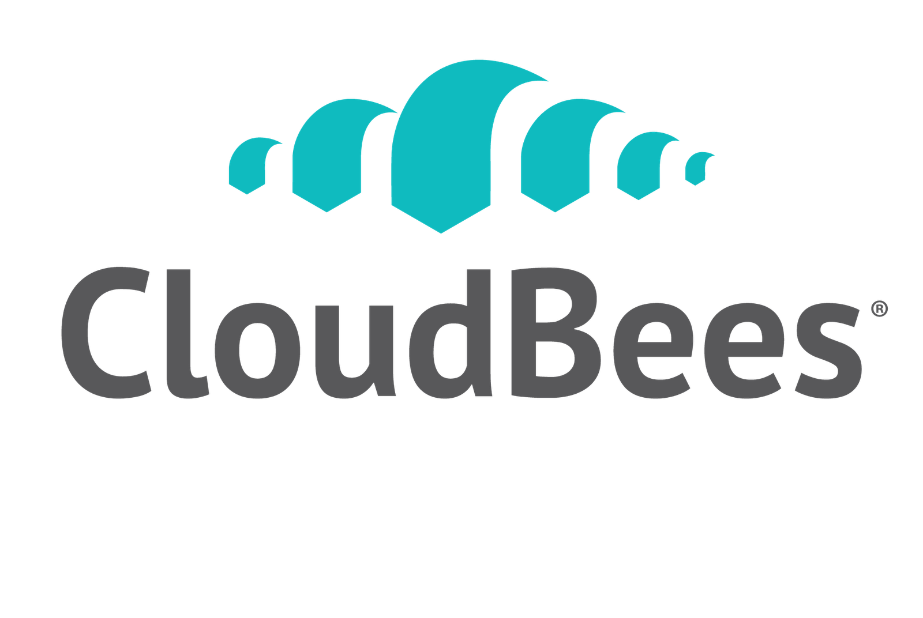

Continuous Integration with Jenkins

Training Labs

Table of Contents

Introduction 3

Lab 1: Installing the lab environment 4

Lab 2: Creating a Freestyle build job 9

Lab 3: Creating a Maven build job 13

Lab 4: Displaying test results 16

Lab 5: Creating an integration tests build 20

Lab 6: Integrating with a source repository browser 23

Lab 7: Code quality metrics 27

Lab 8: Code coverage metrics 32

Lab 9: Command-Line Interface 35

Lab 10: Access control 38

Lab 11: Build Promotion 46

Lab 12: Parameterized builds 55

Lab 13. Automatic deployments to Tomcat 58

Lab 14: Distributed builds 62

Lab 15. Creating a folder 66

Lab 16. Role-Based Access Control 69

Lab 17. Validated merge 83

Lab 18. Builder template 93

Lab 19. Job template 97

Lab 20. Auxiliary template 102

Lab 21. Update Center 110

# Introduction

This workbook is designed to supplement your CloudBees Jenkins training. It consists of a sequence of lab exercises that will introduce continuous integration concepts and Jenkins best practices.

These lab exercises should be completed in sequence and in the presence of an instructor. The instructor will distribute the software and code necessary to complete these exercises.

A dedicated lab installer will install all the software required for these labs. Your instructor will tell you if this has already been done on your machine, or if you need to do so yourself.

If you encounter problems with your software installation or if you do not understand any of the instructions, please ask your instructor for help.

# Lab 1: Installing the lab environment

Goal

The aim of this lab exercise is to install the lab environment and start Jenkins on your machine.

Step 1. Install the lab environment

Execute the lab installer provided on the lab USB sticks. This file is called ‘setup.exe’. This will install all the software required for the labs.

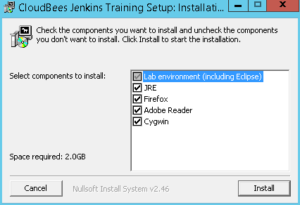

The installation process will also propose to install the Java JRE, Acrobat Reader and Firefox, if you do not already have them installed. If you select these options, the installer will run a separate installation program for each of these applications.

The installer comes with its own bundled JDK, and will update the user’s path and JAVA_HOME environment variable to use this JDK.

Step 2. Start Jenkins

To start Jenkins and the associated servers we need for the labs (Subversion, Nexus, Tomcat and so on), go to ‘CloudBees/Jenkins Training’ in the Windows menu and select ‘Start Servers’.

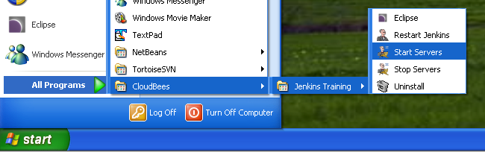

This will start the servers we will need during the labs, and run them in a number of DOS windows. DO NOT CLOSE THESE DOS WINDOWS. Closing them will shut down the corresponding servers, and make it impossible to do the labs correctly. However feel free to minimise them if you want to de-clutter your desktop.

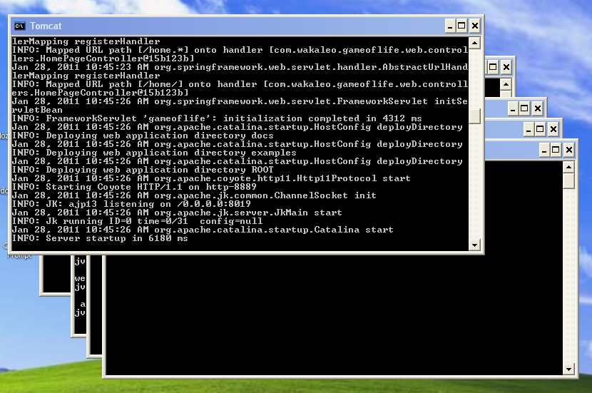

Once you have finished the labs, you can shut down the servers by closing the DOS windows manually, or you can use the ‘Stop Servers’ menu option. Note that in both cases you need to manually stop the Subversion window, as this cannot be done remotely on Windows.

Step 3. Open Jenkins and register

Now open a browser and go to [http://localhost:8080](http://localhost/). You should see the registration page. Select “Use a license key”

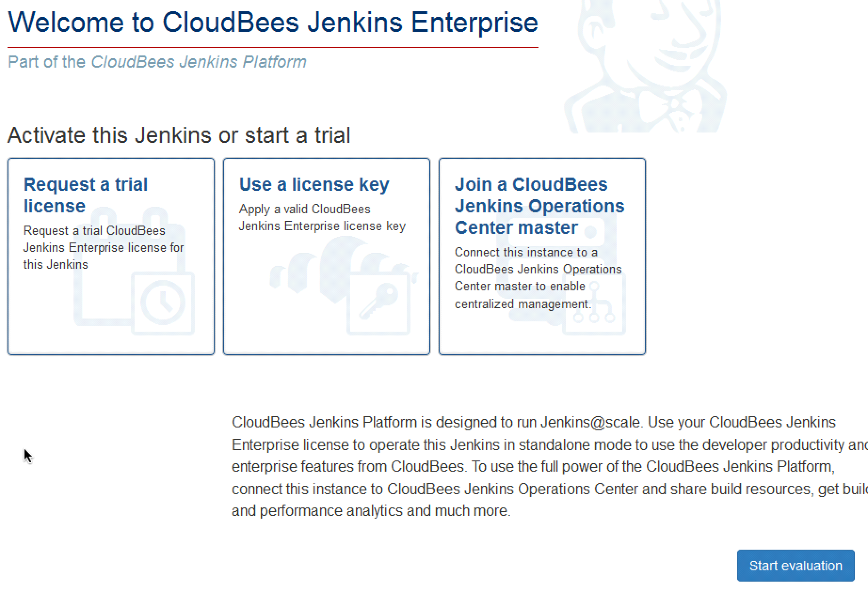

Copy/paste the key & certificate that you will get from your instructor.

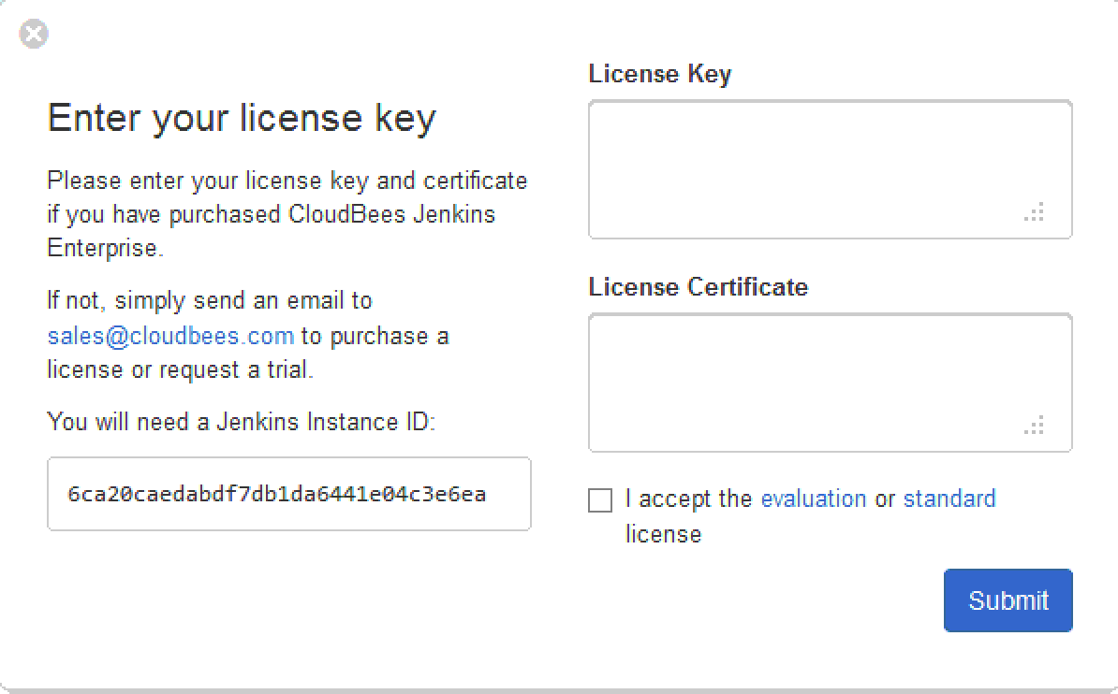

Once the registration is complete, you should see the Jenkins dashboard.

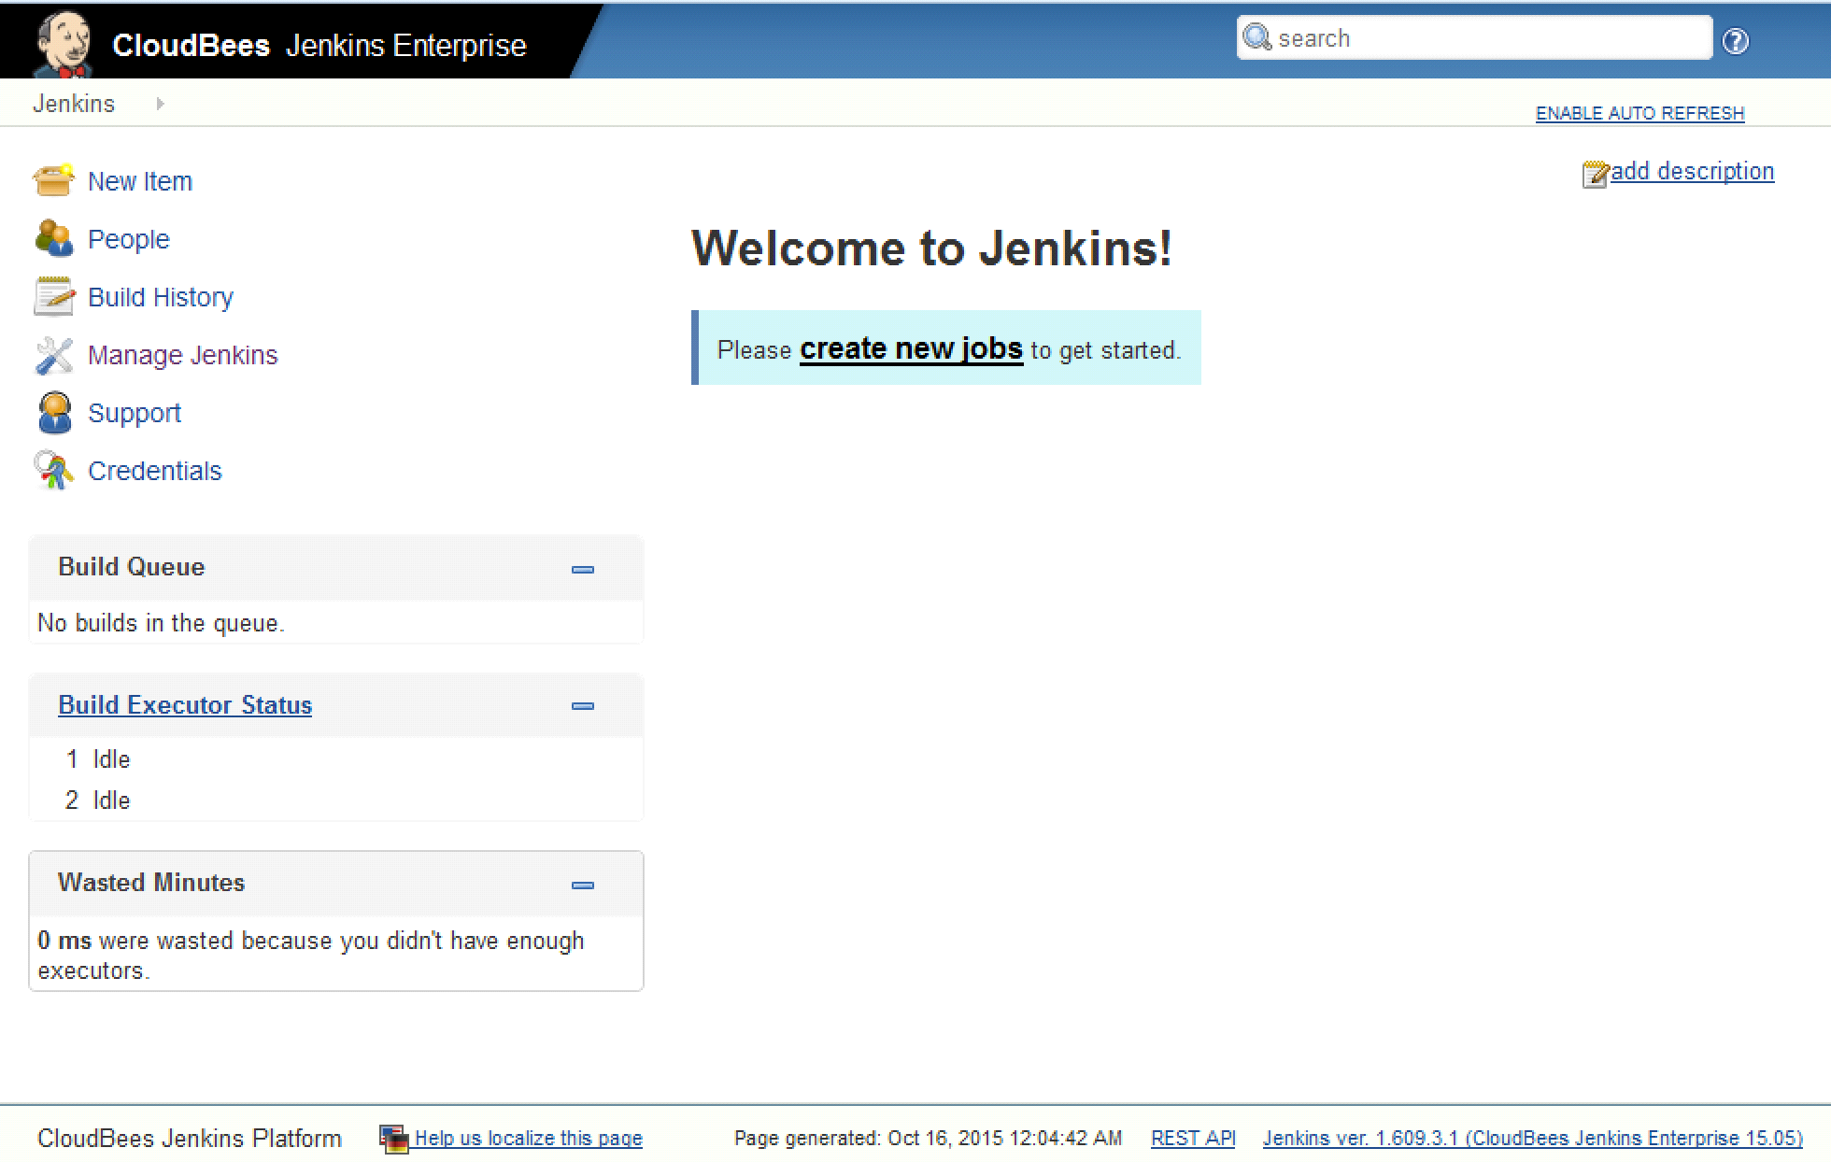

Step 4. Configuring Maven and the JDKs

Now click on the ‘Manage Jenkins’ menu item. Next, click on ‘Configure System’.

For this workshop, we need to configure JDK and Maven. First, configure the JDK installation. Click on ‘Add JDK’ to define new a new JDK configuration, and untick the ‘Install automatically’ option. Next, enter ‘C:\CloudBees\tools\jdk1.6.0’ in the path

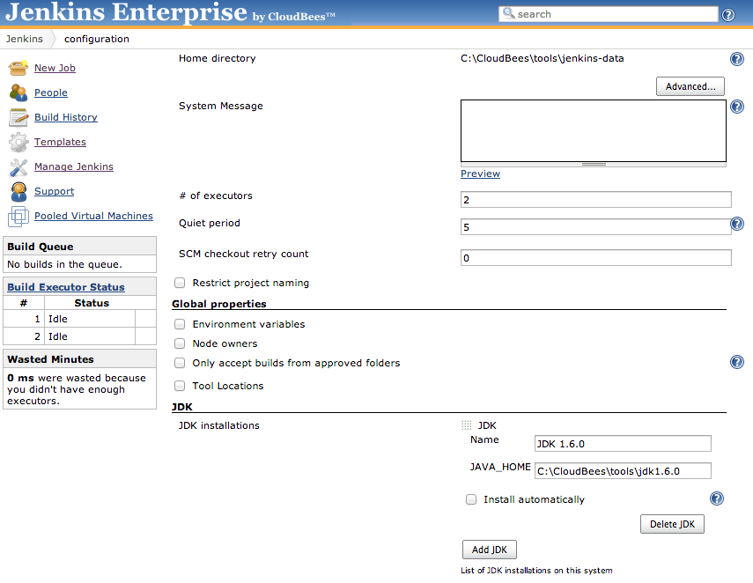

Next, add a Maven configuration in the same way:

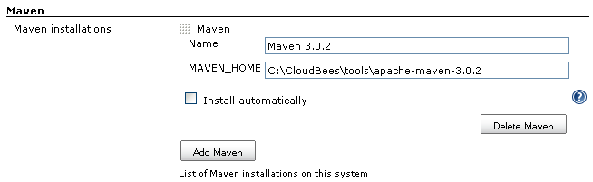

Finally, save this configuration by clicking on the ‘Save’ button at the bottom of the screen.

Step 5. Install Subversion plugin

The license of the Subversion plugin doesn’t allow us to redistribute it with Jenkins Enterprise, so we need to ask you to install it now.

Click “Manage Jenkins” link, then go to the “Manage Plugins” screen.Click the “Available” tab to show all the available plugins, then type “Subversion plug-in” to the filter text box. Click the check box next to the “Subversion plug-in”, then click “install without restart”:

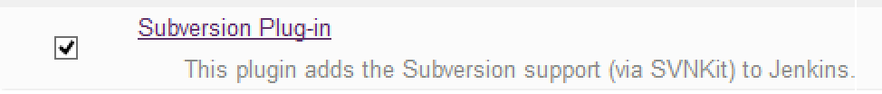

Jenkins will download the new plugin. Once it has successfully downloaded the plugin, you will see a Success message next to the plugin name.

# Lab 2: Creating a Freestyle build job

Goal

The aim of this lab exercise is to configure a simple freestyle build job on your Jenkins server.

Step 1. Create a new build job

Click on the ‘New Job’ menu item on the home page, and choose ‘Build a free-style software project’. Call this project ‘gameoflife-freestyle’ and click ‘Ok’.

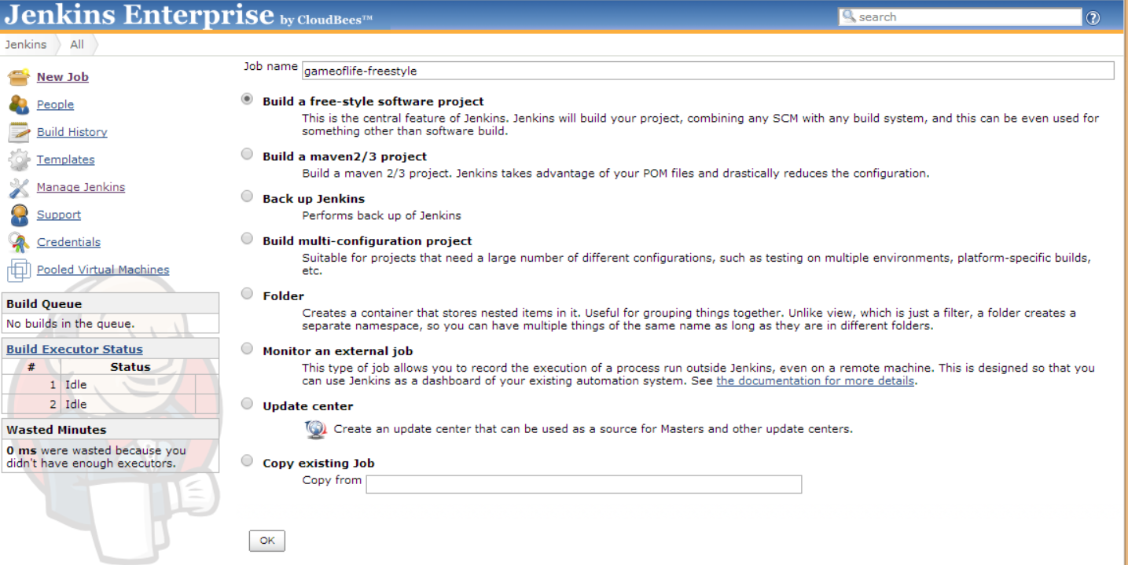

Step 2. Configure the SCM details

For this build job, you need to configure three things. First, choose ‘Subversion’ in the ‘Source Code Management’ section, and enter ‘svn://localhost/gameoflife/trunk’ in the Repository URL.

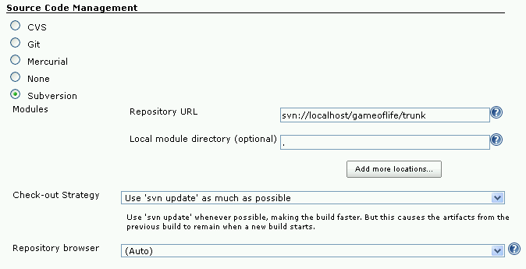

Also enter “.” in the Local module directory. Jenkins may prompt you for a username and password for the Subversion repository: you can enter either ‘harry’ (password ‘harry’) or ‘sally’ (password ‘sally’).

Step 3. Configure the build triggers

Next, set up the build triggers. We will be polling the Subversion repository every minute, so enter ‘* * * * *’ in the ‘Poll SCM’ section:

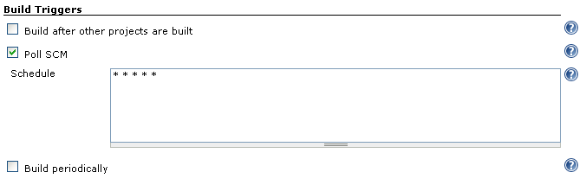

Step 4. Configure the build goals

Finally, you need to configure the Maven build goals. First, add a new ‘Invoke top-level Maven targets’ build step:

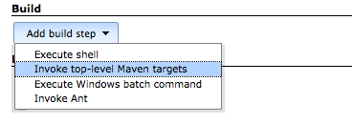

Next, add the following in the ‘Goals and options’ field:

clean install -B -U

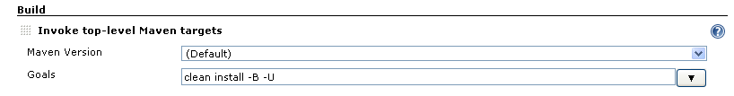

Next, click on the ‘Advanced’ button to enter some extra property values to pass to the build:

surefire.useFile=false

webdriver.port=9091

jetty.stop.port=9998

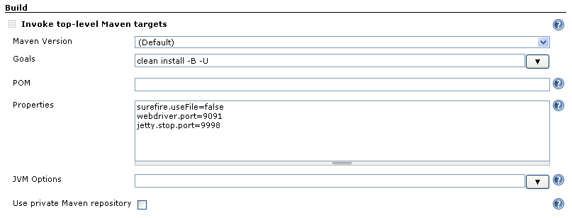

This will compile, test and package the application. The **webdriver.port** and **jetty.stop.port** options are parameters used in the game of life project, that tell Maven which port to run the test application on during the web tests.

Next, you need to tell Jenkins where to find the test results.

Go to the Post-build Actions and tick the ‘Publish JUnit test result report.

Enter the following in the ‘Test report XMLs’ field:

**/target/surefire-reports/*.xml

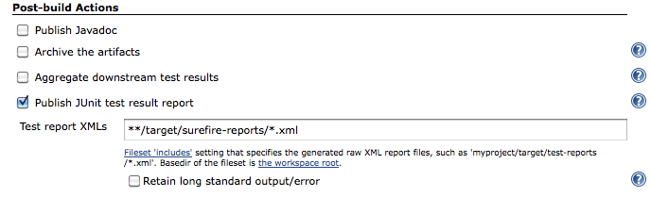

Now save this project. A build should kick off almost immediately. Go back to the dashboard to watch the build in progress.

# Lab 3: Creating a Maven build job

Goal

The aim of this lab exercise is to configure a simple Maven build job on your Jenkins server.

Step 1. Create a new build job

Now click on the ‘New Job’ menu item on the home page, and choose ‘Build a maven 2/3 project’. Call this project ‘gameoflife-default’

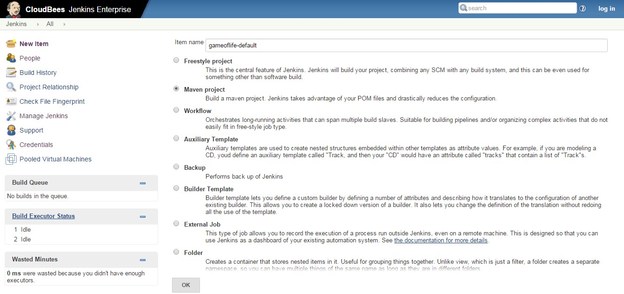

Step 2. Configure the SCM details

For this build job, you need to configure three things. First, choose ‘Subversion’ in the ‘Source Code Management’ section, and enter ‘svn://localhost/gameoflife/trunk’ in the Repository URL. Also enter “.” in the Local module directory.

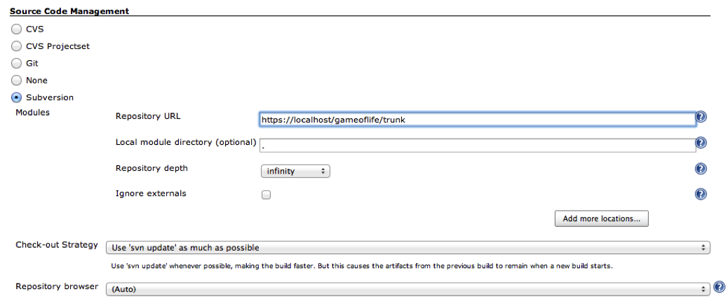

Step 3. Configure the build triggers

Next, set up the build triggers. We will be polling the Subversion repository every minute, so enter ‘* * * * *’ in the ‘Poll SCM’ section:

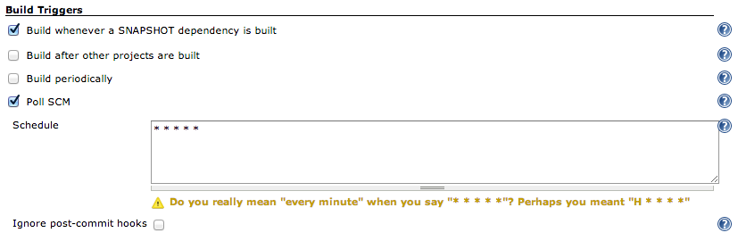

Step 4. Configure the build goals

Finally, you need to configure the Maven build goals. Add the following in the ‘Goals and options’ field:

clean install -B -U -Dsurefire.useFile=false

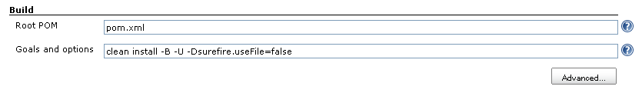

This will compile, test and package the application, and deploy the latest snapshots to the local repository.

Now save this project. A build should kick off almost immediately. Go back to the dashboard to watch the build in progress.

# Lab 4: Displaying test results

Goal

In this lab, you will see how Jenkins displays failing tests. You will need to modify the source code of the application. To do this, open Eclipse using the icon in the CloudBees menu:

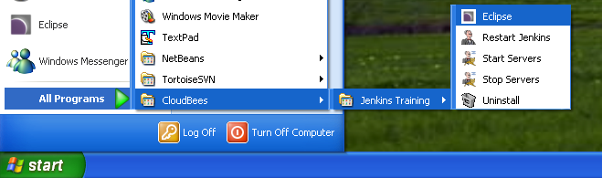

Step 1. Triggering a failed build

This will start Eclipse with the lab workspace, which contains the projects used in the game-of-life builds.

To see how Jenkins reacts to a build failure, we are going to introduce an error into the source code. The application we are testing is an implementation of Conway’s Game of Life. One way to break the build is to change the symbol representing a dead cell from a period (“.”) to something else (say, a dash (“-”)).

You can do this by modifying the Cell.java class as shown here:

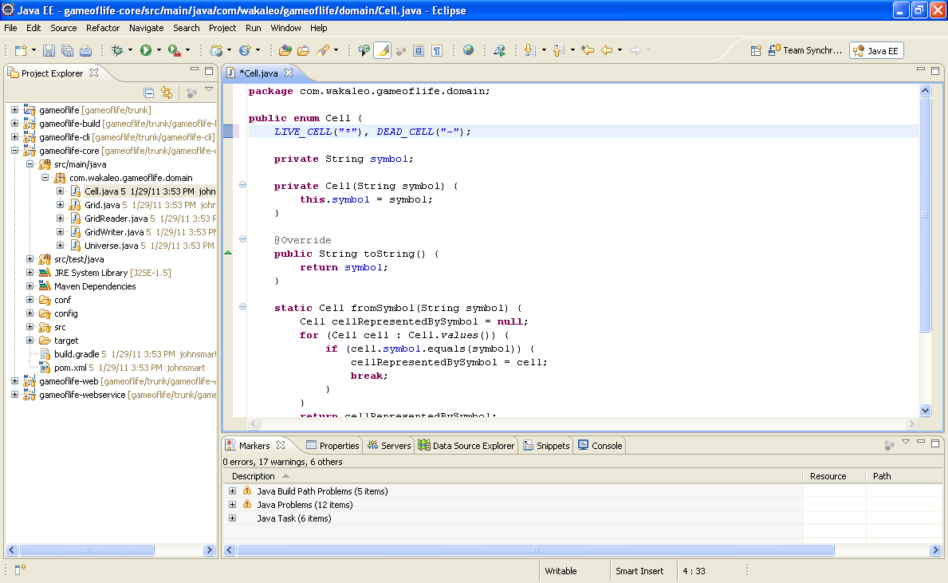

Now commit these changes to the Subversion repository, either from Eclipse or from the command line. From Eclipse:

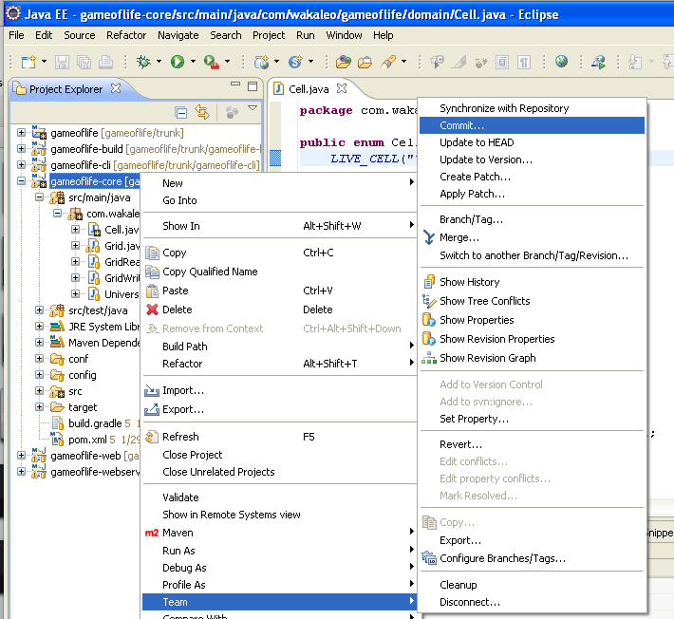

Or, from the command line, go to the C:\Cloudbees\labs\gameoflife directory and enter the following:

C:\Cloudbees\labs\gameoflife>svn commit -m "Changed cell symbol"

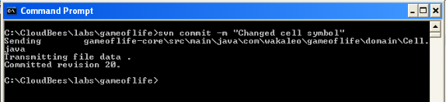

When you commit your changes, you will be prompted for a username and password. Two users have been configured for this repository: harry (password: harry) and sally (password: sally).

Step 2. Look at the failed build in Jenkins

Now go to Jenkins and investigate how Jenkins displays the build failure. Drill down and study the details in some of the test failures. Also investigate the “(trend)” link to see how long the tests take to run over time.

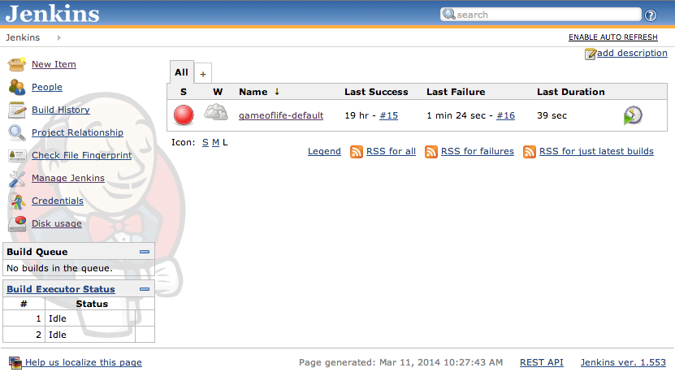

Step 3. Fix the build

Now fix the error and commit the changes to Subversion again. Study how Jenkins displays the record of the test failures in the build history.

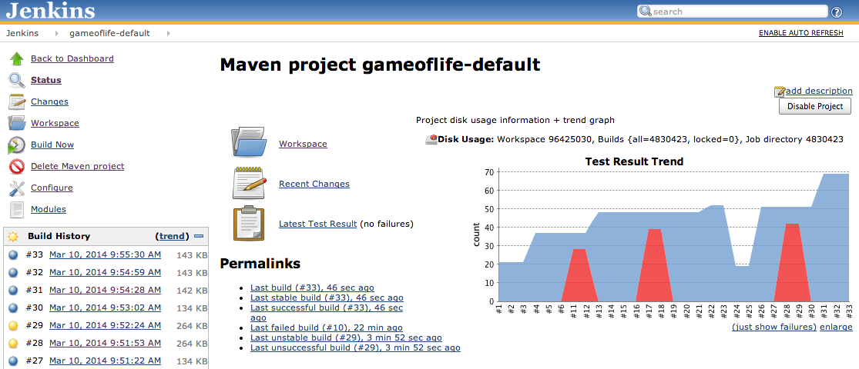

# Lab 5: Creating an integration tests build

Goal

In this lab, you will learn how to create a second build job that is invoked after an initial one. This build job will run the web tests in a Firefox browser, rather than with HTMLUnit as is done in the previous labs.

Step 1

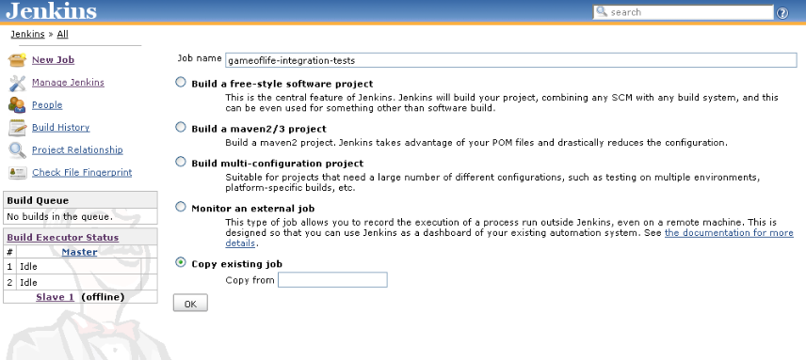In this lab, you will create a job called ‘gameoflife-integration-tests’. This build will run the ‘mvn verify’ command to generate a set of HTML reports about the project. To make things simple, you will just copy your existing ‘gameoflife-default’ project and tweak it:

Step 2

This build will be triggered immediately after the default build job. In the **Build Triggers** section, tick the ‘Build after other projects are built’ checkbox and enter ‘gameoflife-default’ in the corresponding field. Untick the other boxes.

Now change the SCM settings to only check out the ‘gameoflife-web’ module, as shown here:

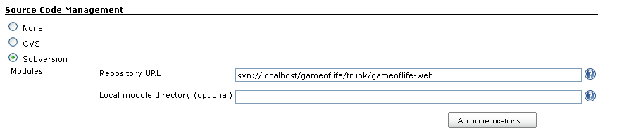

You will also need to change the goals. In this test, we need to run the integration tests using Firefox. Replace the ‘Goals and options’ field by the following value (all on one line):

clean verify -B -U -Dsurefire.useFile=false -Dwebdriver.driver=firefox -Dwebdriver.port=9092 -Djetty.stop.port=9997

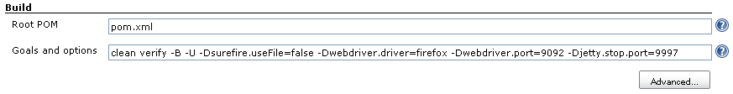

Now trigger the gameoflife-default build manually. This should trigger this new build job, and result in web tests being executed automatically in Firefox:

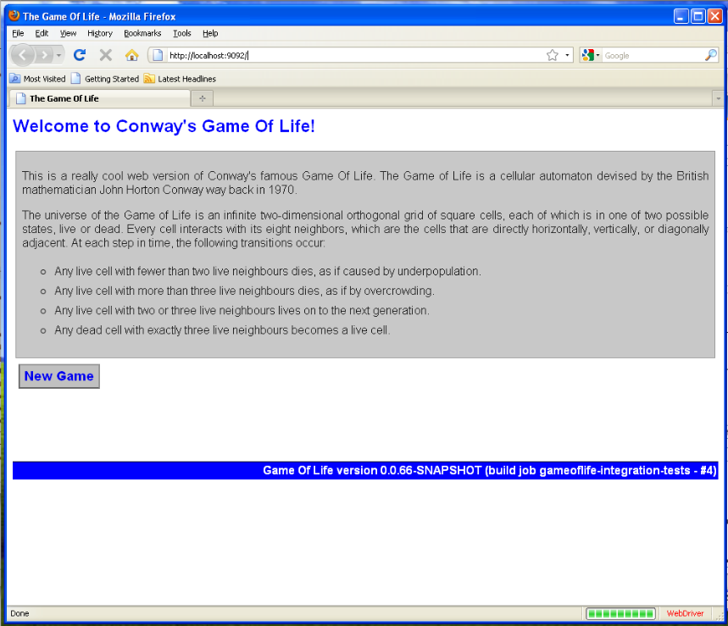

# Lab 6: Integrating with a source repository browser

Goal

In this lab, you will see how Jenkins can integrate with a source code repository browser.

Step 1. Integrate with Sventon

One of the tools installed for this workshop is the Sventon source code repository browser. You can consult this server on the following URL:

[http://localhost:8888/svn/repos/gameoflife/list/gameoflife](http://localhost:8888/svn/repos/gameoflife/list/)

You can configure Jenkins to integrate with Sventon, as well as with other source code repository browsers such as Fisheye and Trac. Go into the configuration screen for the ‘gameoflife-default’ project, and select ‘Sventon 2.x’ in the Repository Browser list in the ‘ Source Code Management’ section. Then add “http://localhost:8888/svn” as the Repository URL, and “gameoflife” as the Repository Instance:

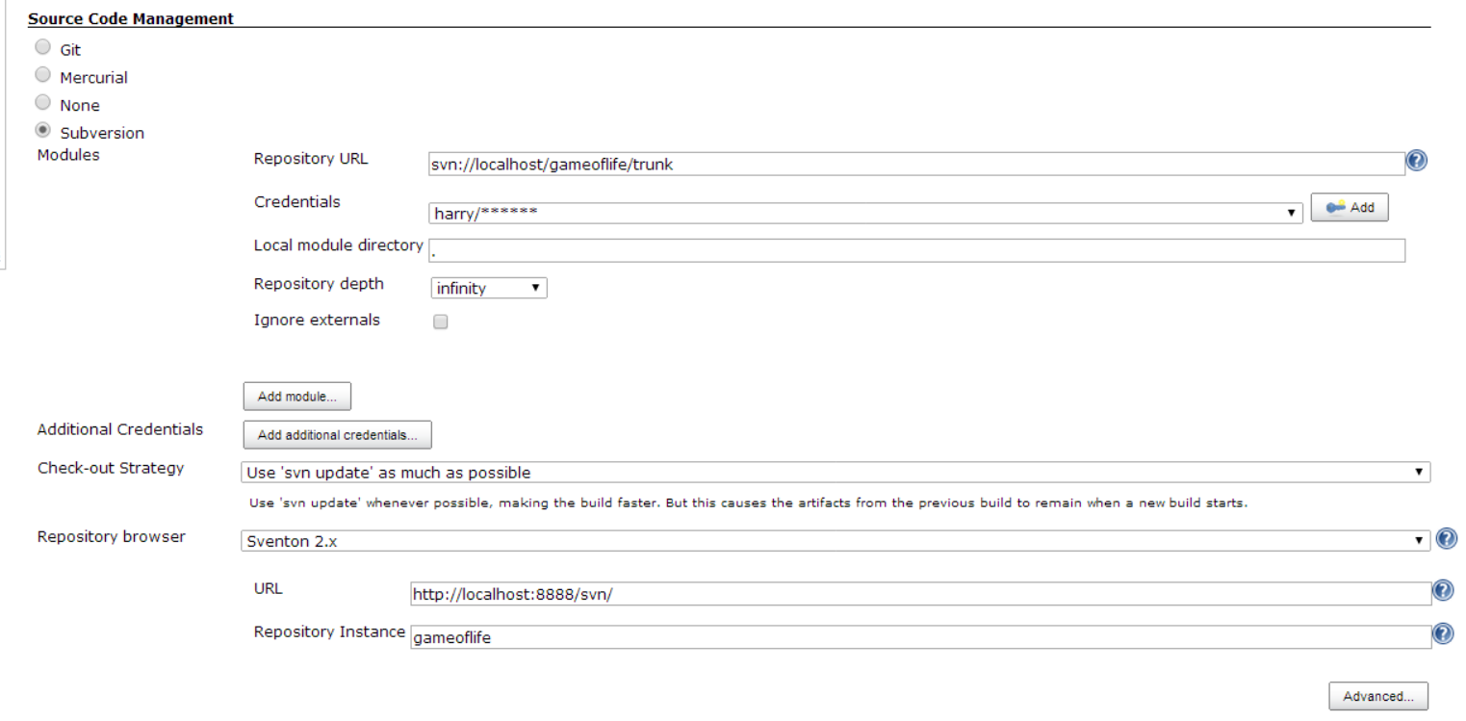

Save your changes.

Step 2. Making a change

Now make a change to the source code in the ‘gameoflife’ project and commit your change to your local Subversion repository.

Open up Eclipse and make one simple (and harmless) change. One place where you can do this is in the pom.xml file in the gameoflife directory. Change the <url> element to point to your Jenkins project, i.e. “<http://localhost:8080/gameoflife-default>”.

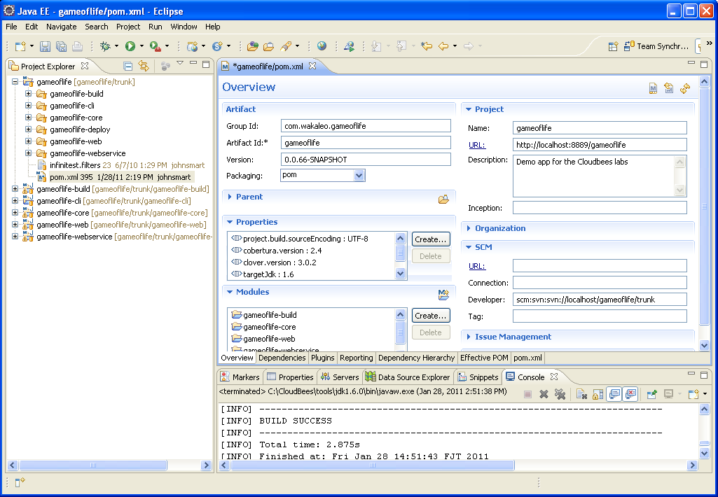

Save your changes and commit them to Subversion, either from the command line or from within Eclipse.

Now watch the build kick off, and click on the “gameoflife-default” build job from the Jenkins home screen to go to the job’s details page. From here, click on the ‘Changes’ link in the left-hand menu (3rd item in the menu):

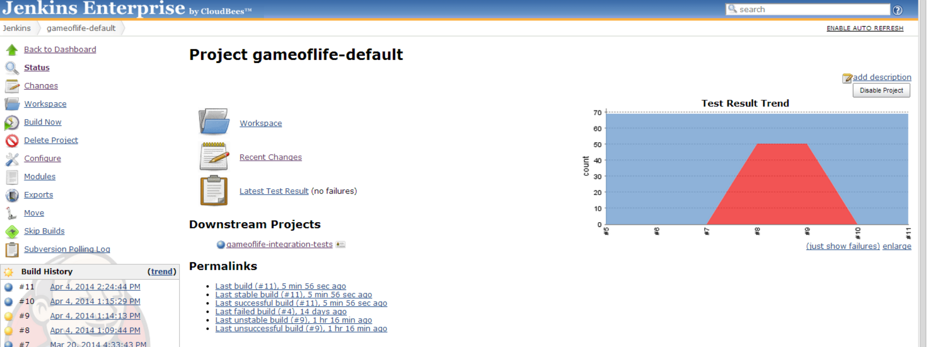

This will take you to a page where you can see a detailed view for each commit by first clicking on the number/date of the build you want to examine:

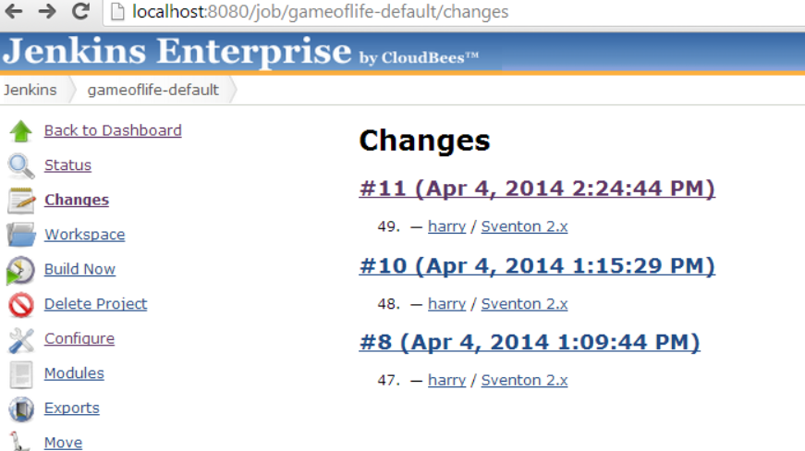

And then clicking on the “diff” link next to the line item that changed:

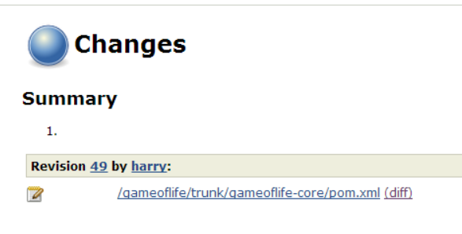

The Sventon plugin will now highlight the lines that changed within the committed code:

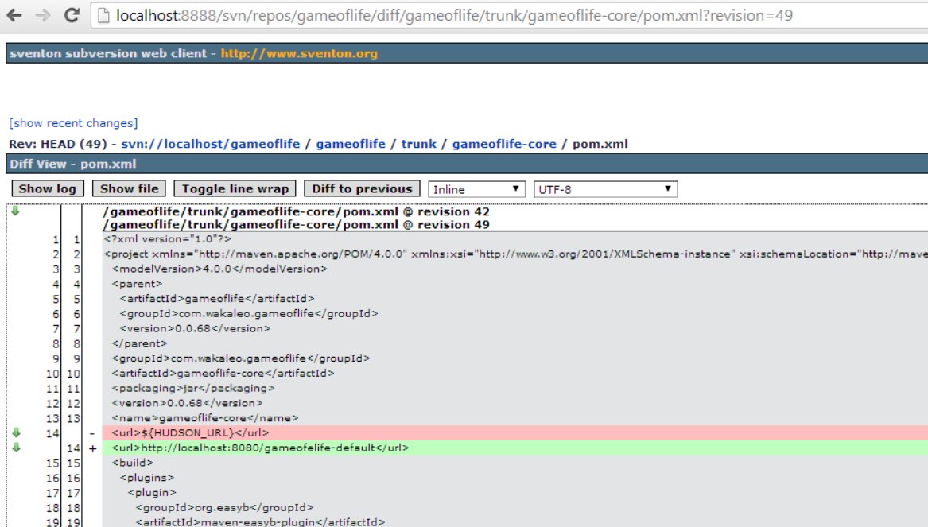

# Lab 7:Code quality metrics

Goal

In this lab, you will learn how to integrate code quality metrics such as Checkstyle, PMD and FindBugs into your Jenkins builds.

Step 1. Install the Violations plugin

First, we need to install the ‘Violations’ plugin, which provides reporting on a variety of code quality-related metrics.

From the Jenkins home screen, click on the “Manage Jenkins” link in the left-hand menu, then click the “Manage Plugins” link:

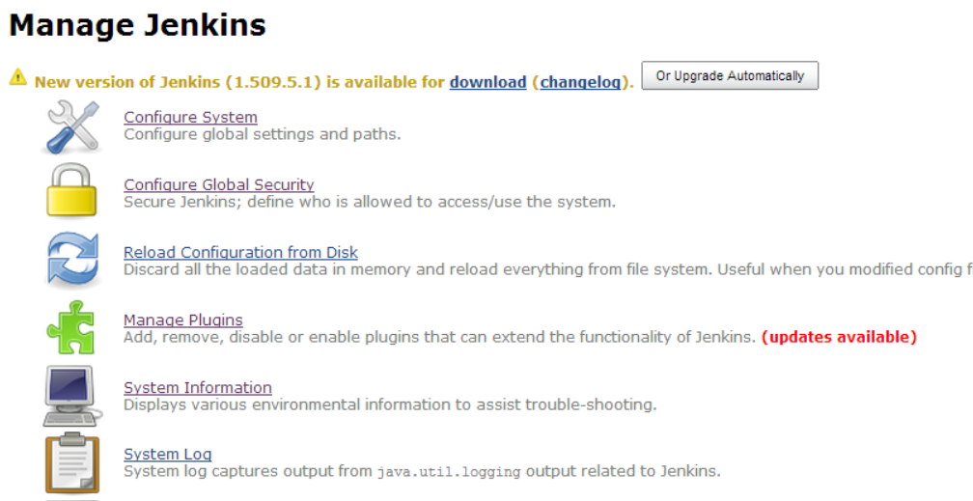

Now we’re going to install the ‘Jenkins Violations plugin’ so that we can make a report from the results of any code quality tests (checkstyle, findbugs, etc).

First, click on the “Available” tab on this page:

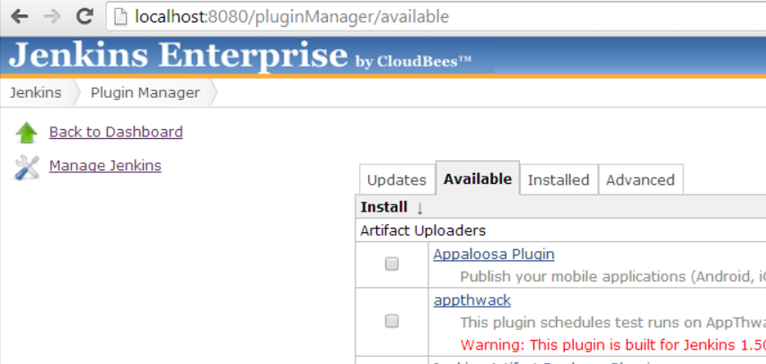

Then search the list of plugins until you find the “Jenkins Violations plugin”:

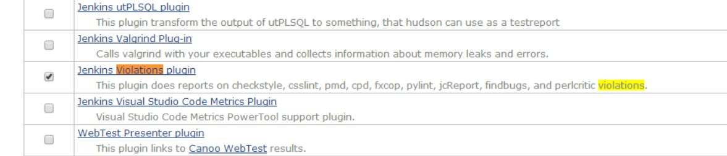

Once you locate it, check the box next to its listing and hit the “Install without Restart” button pinned to the bottom of the page.This will let Jenkins download the new plugin.

Once Jenkins has successfully downloaded it, you will see a Success message next to the plugin name:

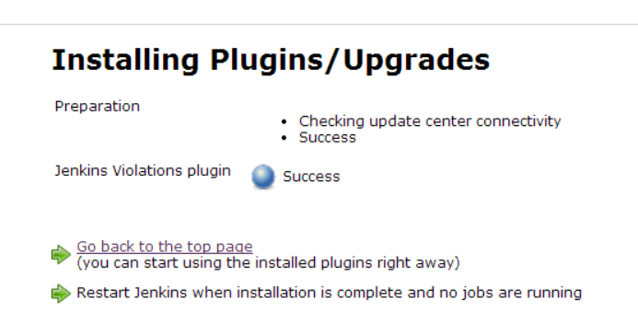

Once this is done, go back to the Jenkins home page.

Step 2. Generate the code quality metrics

The next step involves creating a new build job called ‘gameoflife-metrics’.

As we did for the integration tests, you’ll have to hit the “New Job” left-hand menu item. Name your project “gameoflife-metrics”, and select the “Copy from existing job” option. Type in gameoflife-default” to this field:

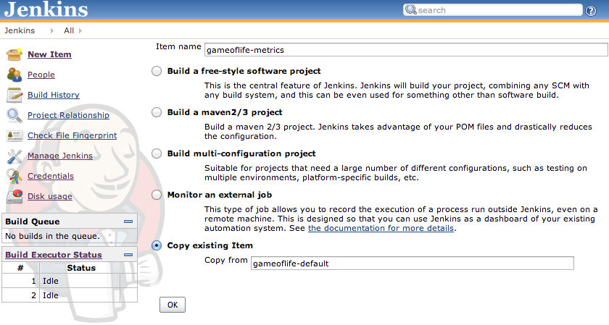

Now we’re goingconfigure this build up to run after the integration tests by configuring the build triggers.

Since this job is copied from the “gameoflife-default” one, you’ll first have to delete the “Poll SCM build trigger. Now, check the “Build after other projects are built” option and name “gameoflife-integration-tests” as the upstream project:

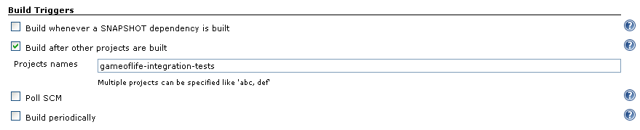

We want a build job that it generates a full set of code quality metrics instead of simply the code coverage ones, so now we’ll change the Maven Goal to the following (all on one line):

clean site -Pmetrics -Pcoverage -B -U -Dwebdriver.port=9093 -Djetty.stop.port=9996

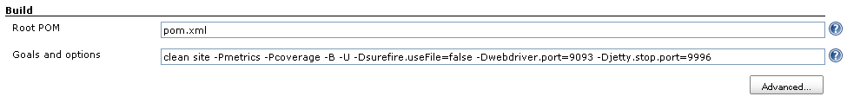

Code quality metrics need plenty of memory, so click on the ‘Advanced’ button and set “JVM options” field to “-Xmx256m”.

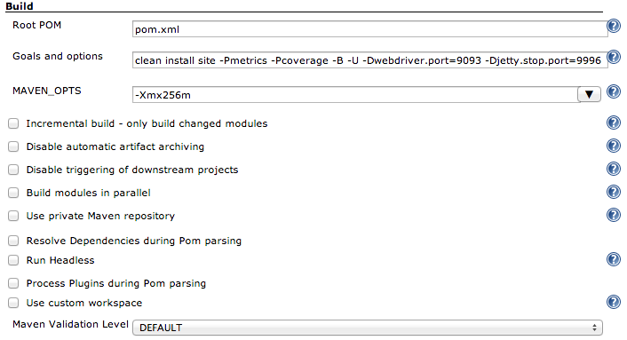

Next, go to the “Build settings”section and tick the “Violations” option. For a Maven project, this plugin knows where to look to find the Checkstyle, PMD and Findbugs XML reports, so you can leave the default settings.

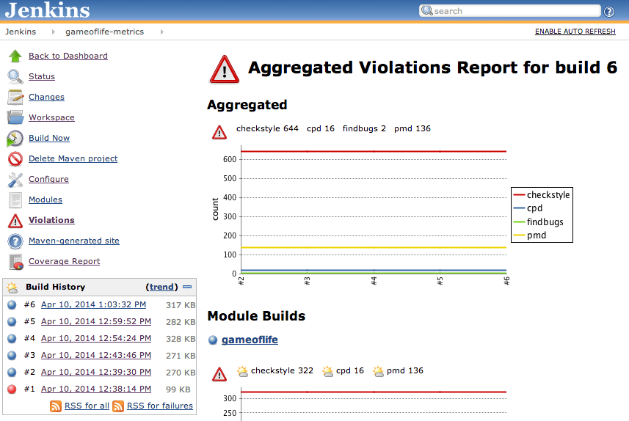

Drill down into the modules to see how the detailed metrics are reported:

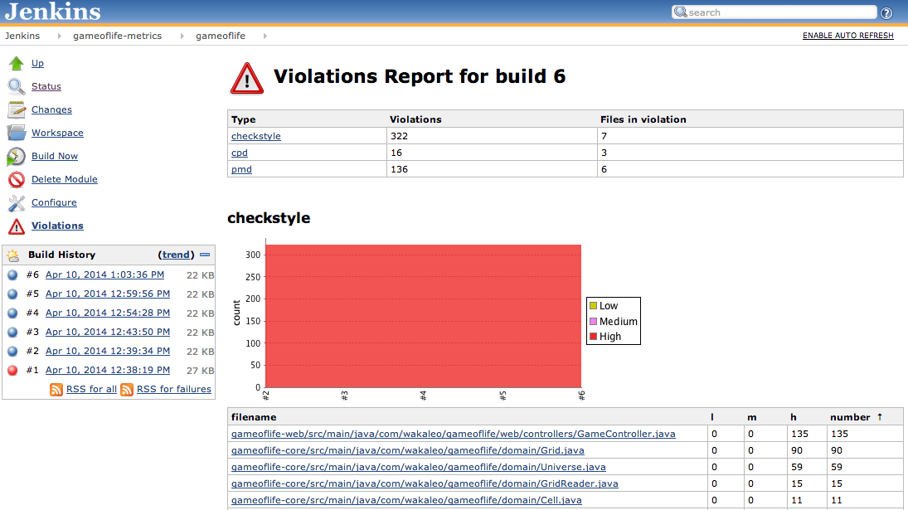

# Lab 8: Code coverage metrics

Goal

In this lab, you will learn how to integrate code coverage into your Jenkins builds.

Step 1. Install the Cobertura plugin

The goal of this lab is to integrate Coberturainto the gameoflife project so we can use Jenkins to display the code coverage metrics, since Cobertura is an open source code coverage plugin.

The first thing we will do is install the Cobertura plugin. As we did earlier, click on the “Manage Jenkins” link in the left-hand menu, then click on the Manage Plugins link.

Now go to the “Available” tab on the plugin management page and search for the “Jenkins Cobertura Plugin”, then check the box next to the plugin’s name and hit the “Install without Restart” button at the bottom of the page.

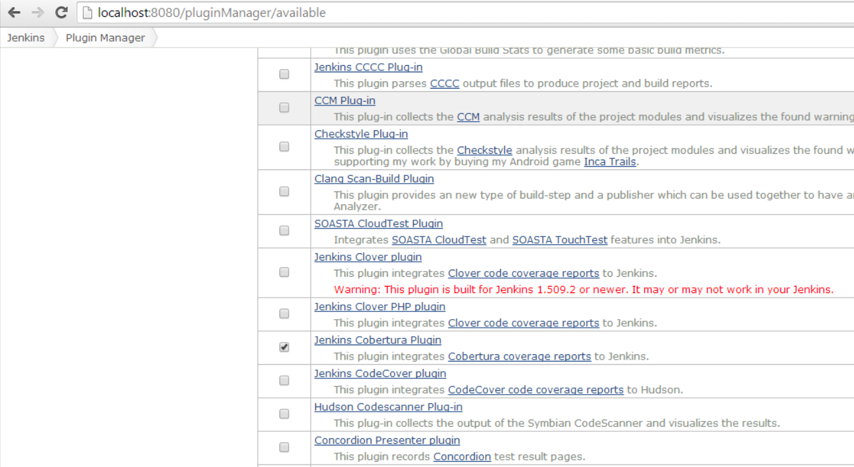

When this is done, go back to the top page of Jenkins by hitting the “Back to Dashboard” link on the left-hand menu.

Step 2. Set up code coverage reporting

We will add code coverage reporting to the ‘gameoflife-metrics’ build job. The ‘mvn site’ command we run already generates code coverage data, we just need to report on it.

Open the build job configuration page, go to the ‘Post-build Actions’ and select the ‘Publish Cobertura Coverage Report’ option.

Enter “**/target/site/cobertura/coverage.xml” in the “Cobertura xml report pattern” field. You can ignore the “Advanced” button for now, but make sure you hit the “Save” button on the bottom of the screen.

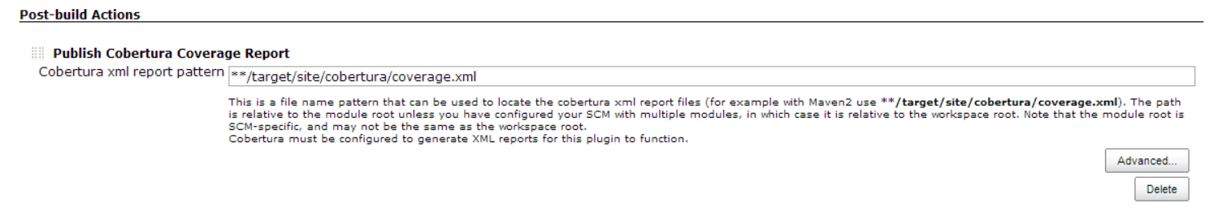

Now let the build run, and then consult the new code coverage metrics reports:

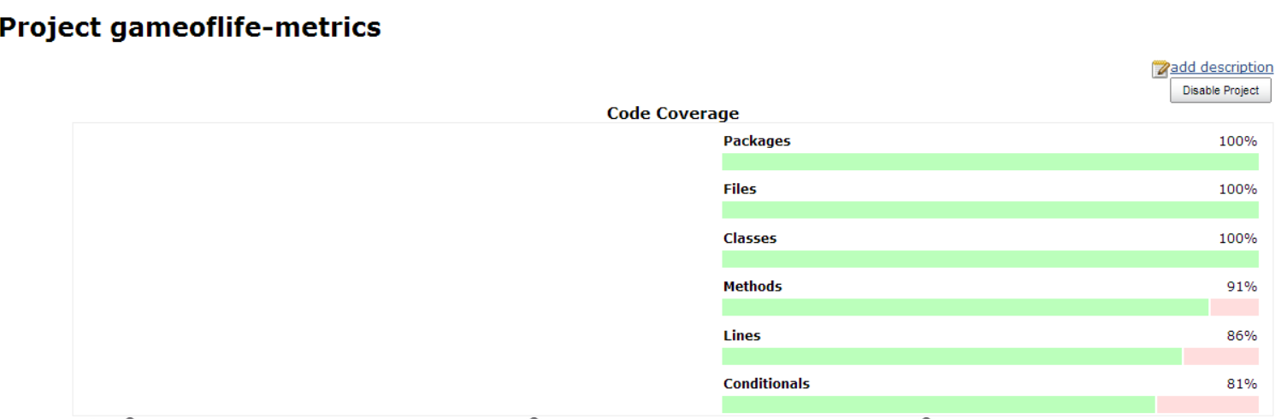

Now click on either the graph itself or the “Coverage Report” link on the build’s summary page to see the detailed breakdown:

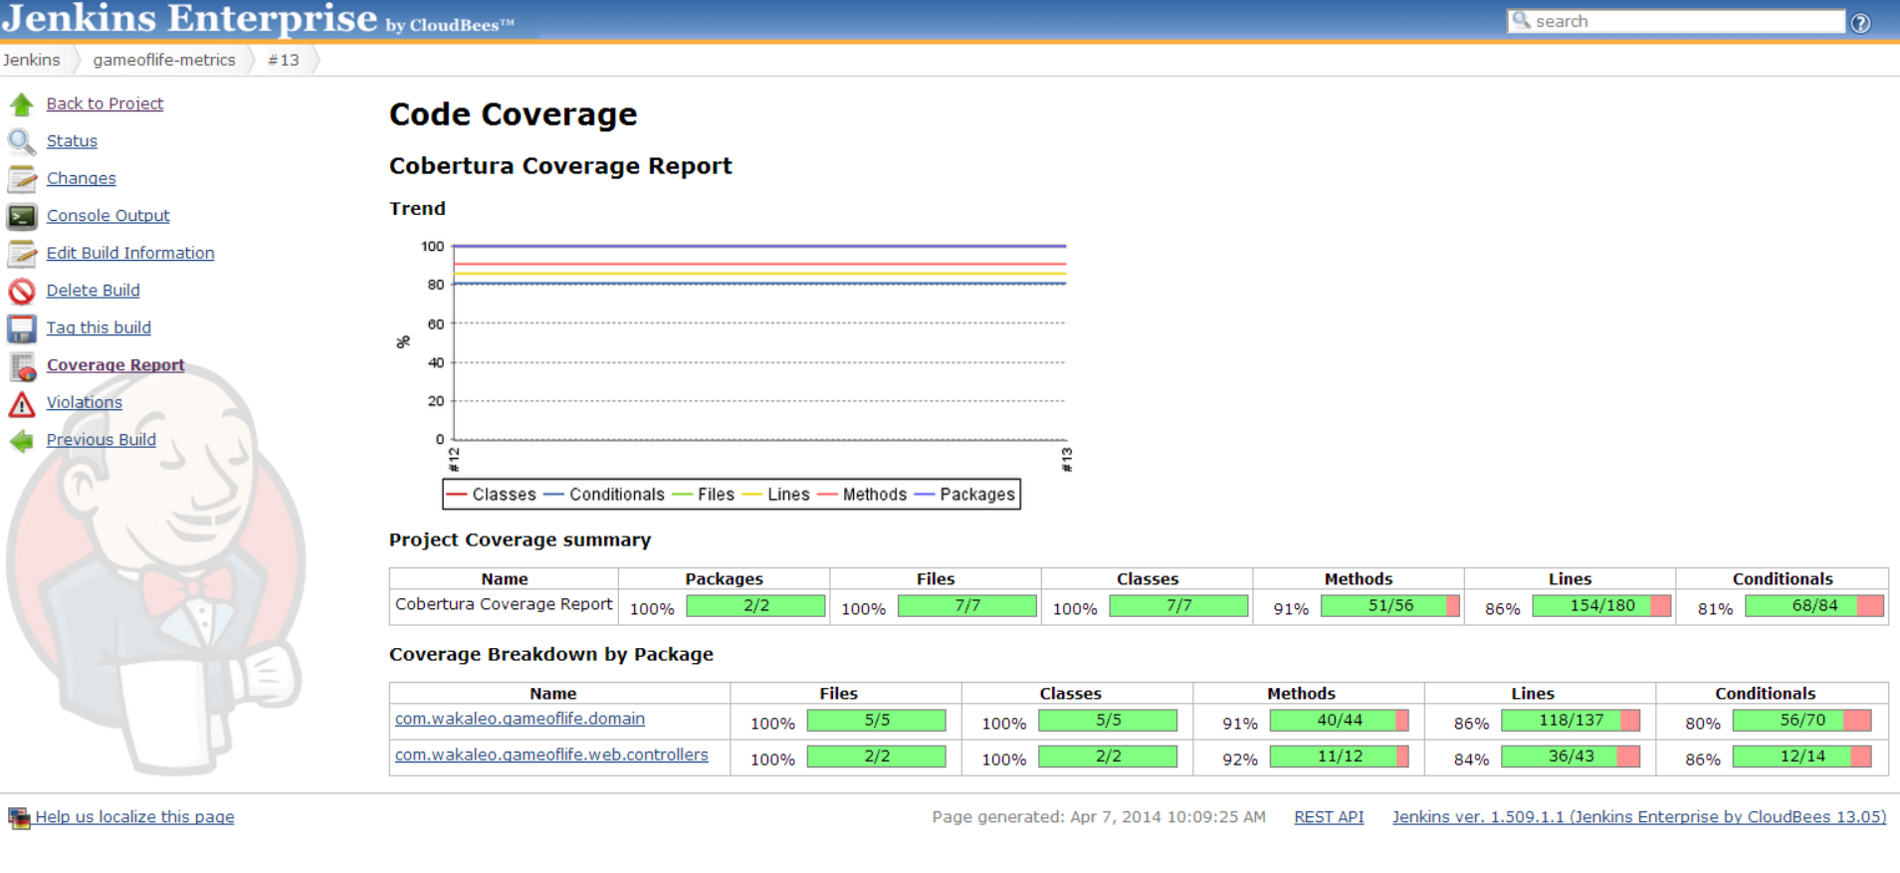

# Lab 9: Command-Line Interface

Goal

In this lab, you’ll get used to the basics of Jenkins CLI, so that it becomes one of the tools in your toolbox.

Step 1. Download jenkins-cli.jar

Go to http://localhost:8080/, click “Manage Jenkins”, and then further click “Jenkins CLI” to get to the Jenkins CLI web page (alternatively, you can directly go to this page by navigating tohttp://localhost:8080/cli)

Download jenkins-cli.jar by clicking the link.

Step 2. Run the help command

Open command prompt by running “cmd.exe” from “Run…” in the start menu.

Copy the downloaded jenkins-cli.jar into the current directory for the convenience (tip: if you drag a downloaded file into the command prompt, it’ll paste as a full path name. This makes the copy easier.)

Run the following command and verify that it’s producing output (all in one line).

C:> java –jar jenkins-cli.jar -s http://localhost:8080/ help 2>&1 | more

Set Jenkins URL as the ‘JENKINS_URL’ environment variable so that you don’t have to keep retyping long URL:

C:> set JENKINS_URL=http://localhost:8080/  
C:> java –jar jenkins-cli.jar help

It should produce the same output.

Step 3. Run a build

Let’s execute the “gameoflife-freestyle” project we created earlier from command line. The -s option makes the command wait for the completion of the build.

C:> java –jar jenkins-cli.jar build –s gameoflife-freestyle

For extra credit, try the command again, but this time manually abort a build while it’s going on. CLI will report a failure. Try also running with the -c option, and verify that the build is skipped.

Step 4. Create a job

Let’s programmatically create a job. Creating a job from CLI requires you to define a job in the XML format. Writing this from scratch is too hard, so we’ll do cut&paste.

Navigate to http://localhost:8080/job/gameoflife-freestyle/config.xml in the browser. You should see the XML definition of this job. From a context menu, select “view source” to reveal the raw XML, then copy&paste it into notepad.

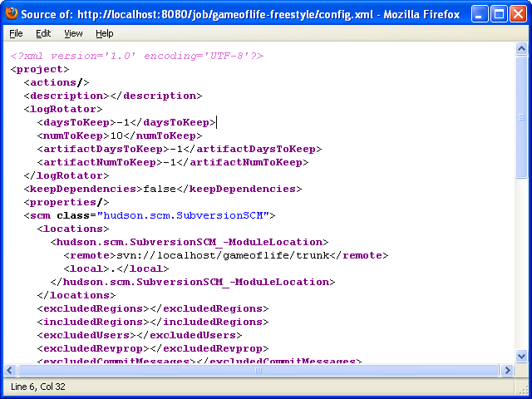

While you are at Notepad, try making some changes to this XML. A very easy change is to add something inside the description element. Jenkins tolerates errors in XML well, so long as it’s well-formed, so try making other changes if you can. Make sure you don’t have whitespace in front of the <?xml…?> declaration, for that breaks well-formedness.

Save this document to somewhere (say “c:\job.xml”) and remember its location.

Go back to the command prompt, then execute the following command (all in one line).

C:> java –jar jenkins-cli.jar create-job gameoflife-copy < c:\job.xml

From the browser, verify that you have the new job named ‘gameoflife-copy’.

# Lab 10: Access control

Goal

In this lab, you’ll learn how to set up access control on Jenkins, and how to successfully trouble-shoot and recover from problems.

Step 1. Install OpenID plugin

In this exercise, we’ll use OpenID as the authentication mechanism, just because it has the least external dependencies.

To do this, we’ll need to first install the OpenID plugin. As we’ve done before, go to the Plugin Manager screen and click on the available tab, then search for the OpenID plugin (named “openid” in all lowercase letters):

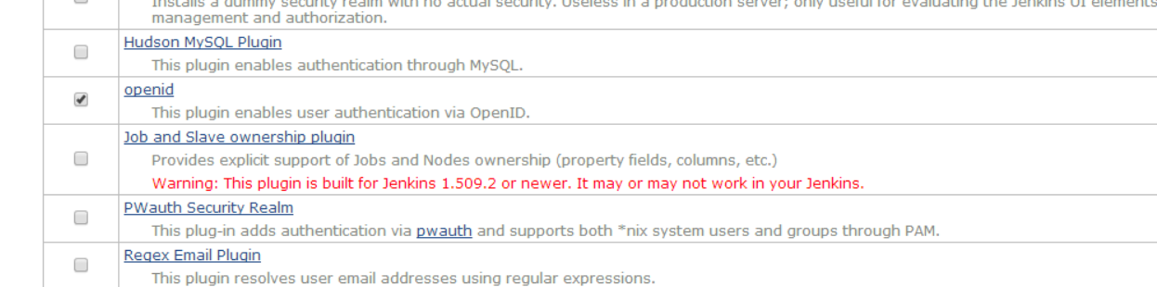

Install the plugin and go back to the top page of Jenkins.

Step 2. Configure OpenID SSO realm

We’ll now enable OpenID authentication.

Go to the system configuration page by clicking on the “Manage Jenkins” link in the left-hand menu and the clicking the “Configure Global Security” link:

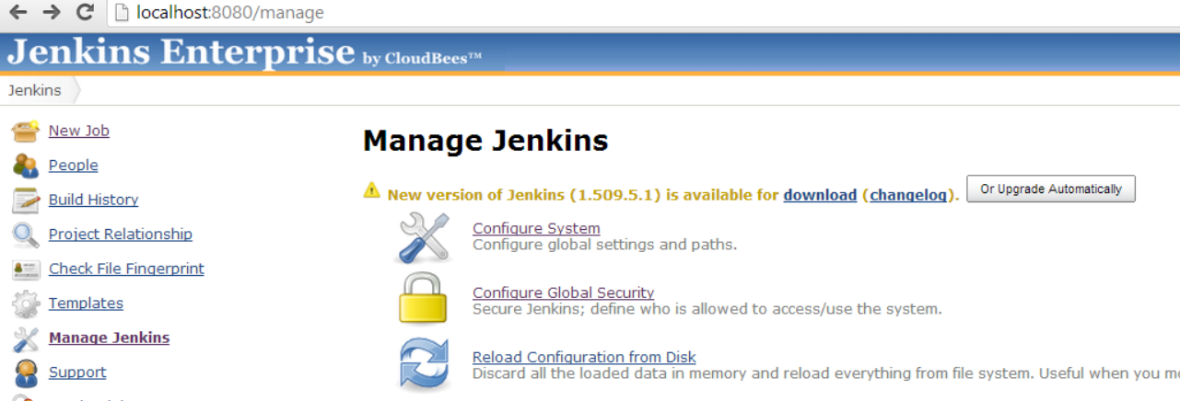  
  
Now tick the“Enable security” box, then click “OpenID SSO” under “Security Realm”:

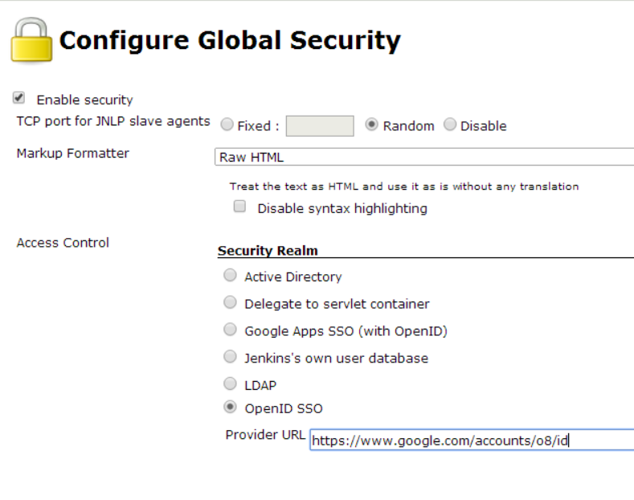  
Now type in https://www.google.com/accounts/o8/id in the provider URL (that’s lower case O, not zero), which is the OpenID endpoint for Google.

If you don’t have a Google account, you can create one, or you can sign up on myOpenIDhttp://myopenid.com/and type http://username.myopenid.com/ as the provider URL. If you already are familiar with OpenID and wish to use other endpoints, feel free to do so.

For the time being, leave “Authorization” to “Anyone can do anything.” This ensures that you can still change the configuration even when you experience some login problems.

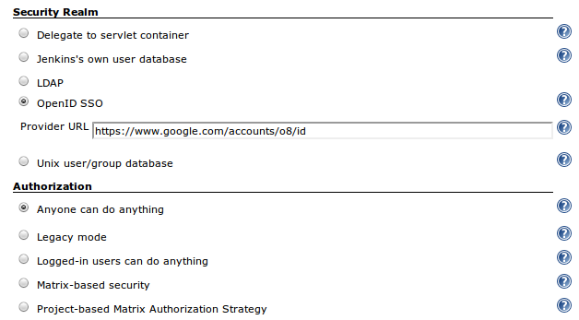

When you are done, hit “Save” to commit your changes.

Step 3. Login and verify your identity

Now we’re going to verify that we set up the SSO authentication correctly.

Click the login link in the top right-hand corner of your screen. You should now be prompted by Google to give your Jenkins instance access to your email address and account info for your login:

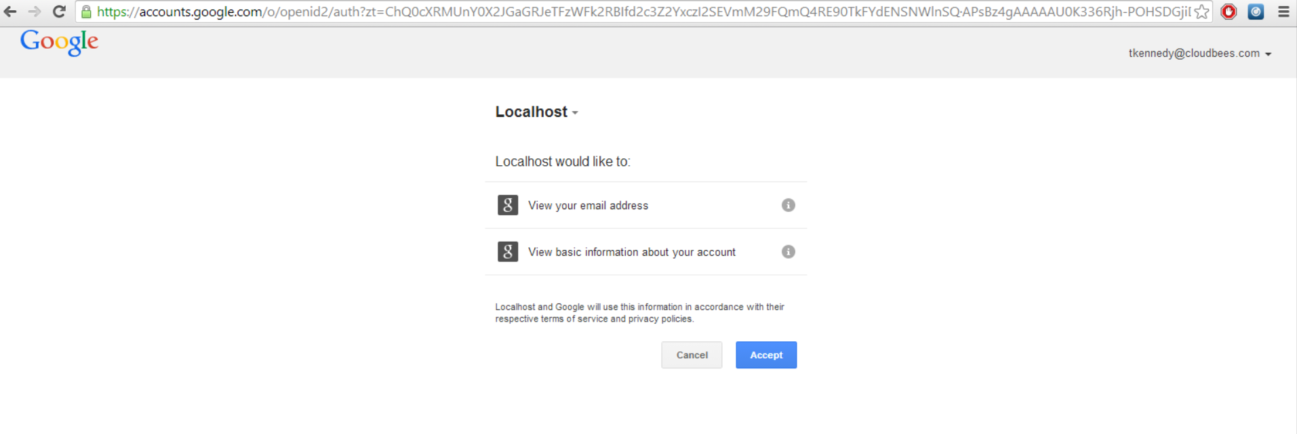

Hit accept, and you should now be logged in and see your Google ID in the top right-hand corner: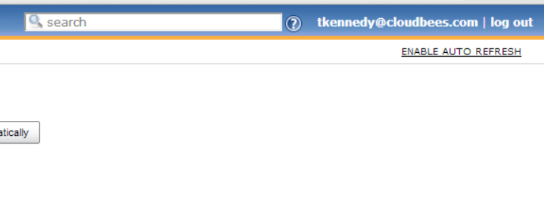  
  
Click on that ID, click the “Configure” link in the left-hand menu. Now we’re going to make sure that your e-mail address is correctly recognized by Jenkins:

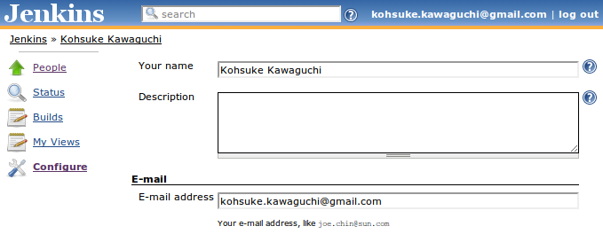

Log out, log back in, and observe that this time you were not prompted of the password (provided that you told your OpenID provider to remember this site.)

Visit http://localhost:8080/whoAmI(case sensitive) and see your current authentication information. Log out, visit the page again and see the details change. When done, log back in.

Step 4. Set up project-based matrix authorization

Now let’s actually enforce access control. In this exercise, we’ll set things up such that we can control visibility of the projects differently from one project to another.

Open the system configuration page by clicking on the “Manage Jenkins” link in the left-hand menu and then clicking on the “Configure Global Security” link that we followed before to activate OpenSSO.

Now scroll down to the “Authorization” section and select “Project-based Matrix Authorization Strategy”:

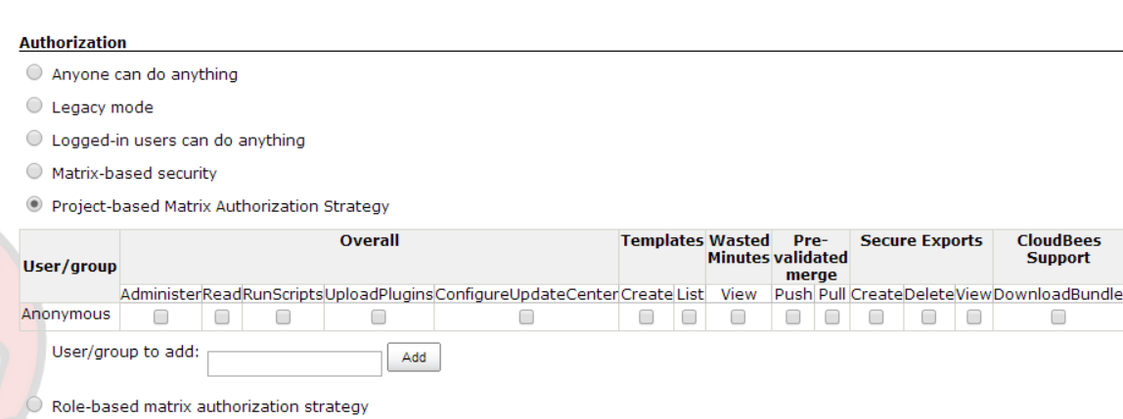

First, assign the overall read access to the anonymous user by checking the “Read” box under the “Overall” permissions column.  
  
Now we’re going to assign the overall administer access to yourself.  
To do this, copy and paste your user ID from the top right-hand corner of the page and paste it into the “User/group to add” field, then hit the add button.

Once you’ve done that, check the “Administer” checkbox under the “Overall” permissions column:

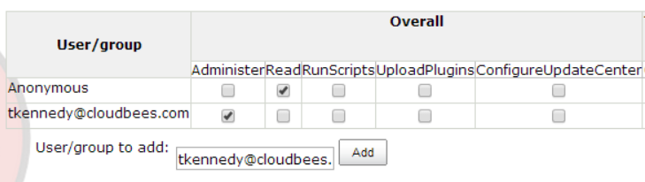

There’s no need to click all rows for yourself, as the administrator access implies all the other privileges.

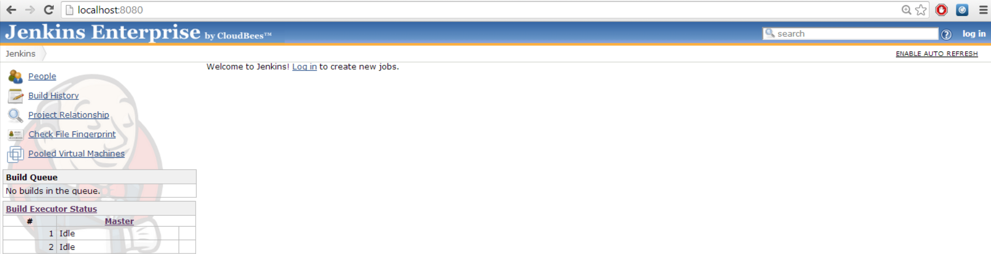Now let’s save these changes by hitting the “Save” button on the bottom of the screen. Log out and login to observe the difference in the visible UI menus. In particular, observe that none of the jobs are visible until you login:

If you were using security realm like Active Directory or LDAP, which supports the concept of groups, you can add group names instead of user names to simplify managing their permissions.

Step 5. Make the project visible to anonymous users

Let’s make some projects visible to anonymous users. Open the job configuration of the gameoflife-default project by clicking on the project’s name from the Jenkins top page and then clicking on the “Configure” link in the left-hand menu.  
  
At the beginning of the job will be a list of checkboxes –tick the“Enable project-based security” box, and then assign the read access to anonymous user by checking the “Read” box under the “Job” configuration heading:

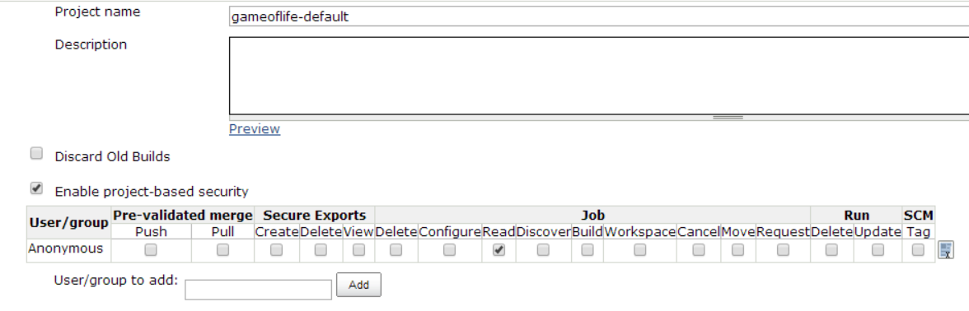

When done, save this setting by hitting the “Save” button.

Log out / login and verify that you can see this project even when you aren’t logged in:

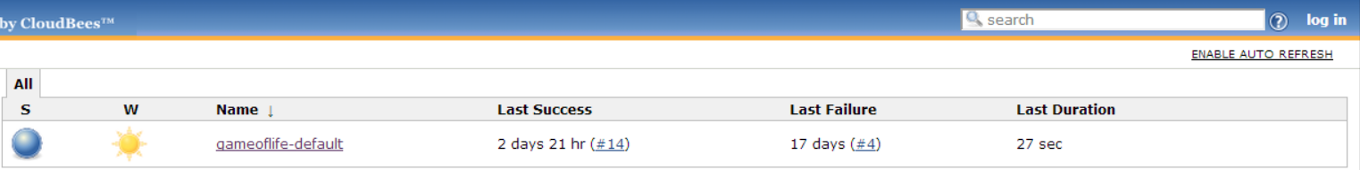

Step 6. Add the “Create Job Advanced” plugin

So far we’ve achieved a “closed by default” set up that allows some projects to be visible selectively. Now let’s add the“Create Job Advanced” plugin to create an“open by default” set up that starts new projects in the publicly visible mode, with options to “close” it down.

Install the “Create Job Advanced” plugin using the same methods in previous labs (“Manage Jenkins”->”Manage Plugins”->”Available”):

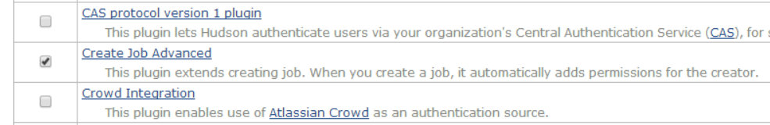

After successfully installing it, go back to the top page of Jenkins.  
  
Now we need to edit the system configuration in order to activate the plugin. Go to “Manage Jenkins” and then open up the “Configure System” page.  
  
Now scroll down to the “Create Job Advanced” section:

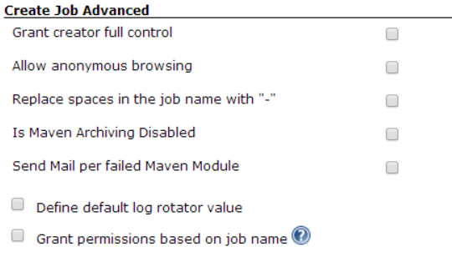  
Check the “Grant creator full control” and “Allow anonymous browsing” options, then save your changes.

Log out, log back in, and observe that this doesn’t affect existing jobs. This plugin is non-destructive.

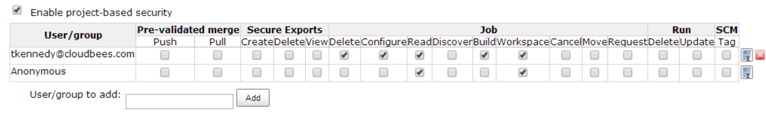Now, log in and create new jobs, and observe that per-project access control table is pre-populated to grant read access to the anonymous user:

Log out, observe that the project is indeed accessible, then log back in.

# Lab 11: Build Promotion

Goal

The aim of this lab is to create a sufficiently real playground for build promotion feature so that you can experiment with different ways of setting it up.

We would have liked to use the projects we’ve built thus far as building blocks, but unfortunately, those are real builds that take time, so here we will create a set of dummy no-op jobs so that we can experiment more easily.

Step 1. Create View And Set Quiet Period to 0

We’ll be creating a number of jobs, so let’s use a view to group them together. Go to http://localhost:8080/ and click the ‘+’ icon on the main tab bar, then enter the view name of your choice (say “promotion playaground”)

Also, go to http://localhost:8080/configure and set the quiet period to 0, so that builds don’t waste any time in the queue.

Step 2. Create CI Job

First, we’ll create a pretend CI job, which runs very frequently. Create a freestyle job, name it “ci”. In the configuration screen, make the following configurations:

* Use “discard old builds” to only keep up to 100 or so builds, so that it will not eat all your disk space
* Click “Build after other projects are built” and enter “ci” in there. In this way, a new build will start as long as one is over, thus we can simulate a busy CI build.
* In the “Build” section, add “Execute Windows batch command” and enter the following script. The first ping command fakes sleep (it runs one ping per second, so this waits about 5 seconds), then the echo command simulates the compilation. %BUILD_TAG% is an environment variable that Jenkins sets that expands to the identifier of this build. We are pretending that this is a compilation of a project:

ping–n 5 localhost  
echo %BUILD_TAG% > a.jar

* In the “Post-build Actions” section, add“Archive the artifacts” to archive a.jar. Also add“Record fingerprints” and click “fingerprint all the archived artifacts”. We need to keep a.jar because we’ll later use this during tests, and fingerprint is needed so that when we run the tests Jenkins can figure out where it came from.

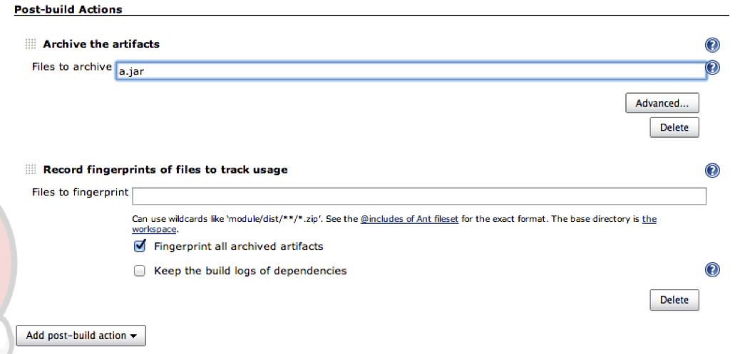

Click save. If you click “Build Now”, it will start churning out new builds automatically. To stop it, abort a build manually.

Step 3. Create QA Job

Next, we’ll create a pretend QA job. This job picks up the jar file built by the CI job and run it through a battery of tests, to identify regressions that are not caught during the compilation.

Go back to the view you created, and add a freestyle job, name it “qa”. In the configuration screen, make the following configurations:

* Use “discard old builds” to only keep up to 100 or so builds, so that it will not eat all your disk space.
* Click “Build after other projects are built” and enter “ci” in there. Here, we are pretending the workflow where we run a test suite as fast as possible whenever new CI build is completed. (This isn’t required to make this lab work – if you prefer, you can do periodic execution, although you’d have to wait longer during the experiment.)
* In the “Build” section, add“Copy artifacts from another project” and configure it to copy a.jar from the last successful build of the CI job as follows. This places the jar file into the working directory so that our test script can access it:

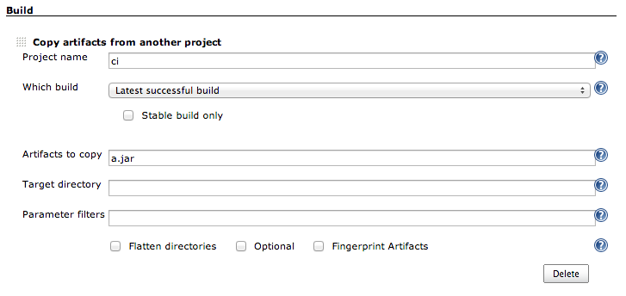

* Add“Execute Windows batch command” into the build section, and enter the following script. The first ping line is to introduce 15 seconds delay. The next “type” line is just to make sure that we do have a.jar available to test. The 3rd line computes a random number from 0 to 9, and in the 4th line, if this random number is less than 5 we are making the build fail. This is simulating a regression caught by the QA test:

ping–n 15 localhost  
type a.jar  
set /A N=(%RANDOM% %%10)  
if /I %N% LSS 5 (fail) else (echo success)

* In the “Post-build Actions”, configure Jenkins to record fingerprint of a.jar as follows:

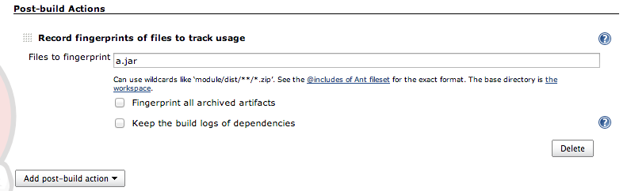

Click save. If you start executing “ci” builds, it’ll start triggering “qa” builds. And you should start them succeed and fail randomly. If you go back to the top page of Jenkins, you’ll observe that the system is busy producing CI builds and test them.

Step 4. Configure Promotion

Now that we have two projects, let’s set up the promotion so that we can overlay the result of the QA job onto the CI job. Go back to the configuration of the “ci” job, and click “Promote builds when…”, then configure this promotion criteria as follows, so that the CI job gets promoted when the QA test passes successfully.

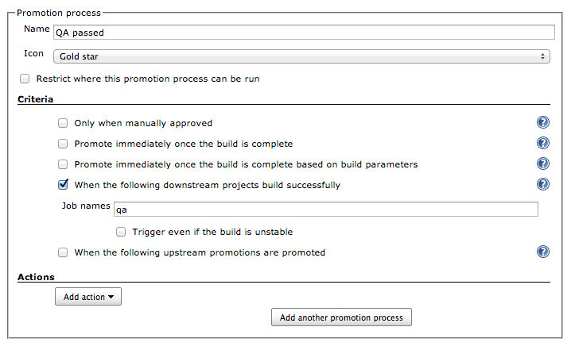

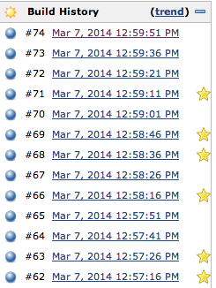Save the configuration, and wait for more builds to appear. If you reload the page, you’ll start seeing the star icon, indicating that the promotion has happened on that build. Abort the CI build to inspect the records.

Click one of the stars to jump to the details of the promotion. Identify the build number of the QA job that qualified the build. Jump to that build, then to its console output, and verify that it is copying the artifact from the right CI build (you’ll find it very early in the console output), the copied jar actually belongs to the correct build (see the output from the type command) and it is promoting the same CI build (this will be at the bottom).

Now, go back to the view and look at the build history of the QA job. There should be some failures. Looks like some of the pretend-commits that our developers are making weren’t very good, so let’s identify what changes have caused test regressions. Click one of the failed QA build, and observe what CI build had a regression. The following screenshot indicates that this failed QA run has tested CI #72, and that the previous QA run has tested CI #71. Thus you can infer that the regression in this QA run must have been caused by some changes made between #71 and #72.

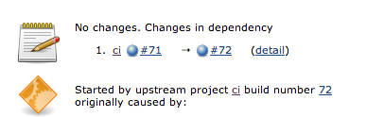

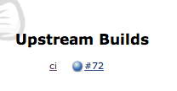

Jump to the upstream CI build and observe that the QA run is linked from there as well.

Step 5. Add Integration Test Job

Let’s expand the previous example further by adding one more stage. In this step, we’ll be adding a pretend integration test job. Imagine we have more exhaustive test that, and it’s expensive to run that we can only run every night. And therefore a build needs to pass a QA test before it can be a subject of the integration test.

Create a free-style job named “int”, and configure this job as follows:

Configure “build periodically” and enter “@daily” because we want to run this nightly (however, in this lab, we’ll just trigger them manually instead of waiting until midnight.)

In the “build” section, add“copy artifacts from another project” and configure it to retrieve a.jar from the last promoted build, as follows. This ensures that we never waste the integration test on builds that didn’t pass QA.

Next, add “Execute Windows batch command” and enter the script as follows, so that we can verify that we are testing the right jar.

Record the fingerprint of a.jar copied above so that Jenkins can correlate which ci build is testing by this job.

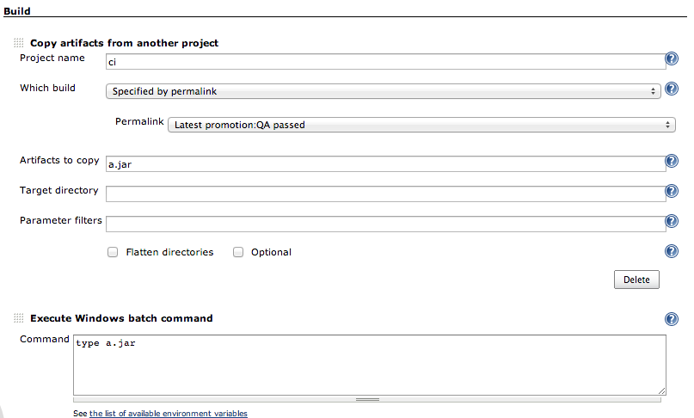

Save this configuration, and manually execute the “int” job, to make sure it succeeds.

Now, we go back to the CI job to set up the 2nd level promotion, so that we can see the status of the integration test job overlaid on top of the CI build records. Go to the CI job configuration, and add another promotion criterion. Configure it as shown in the following picture.

(Note that in the first pass you won’t be able to configure permalink target to “Latest promotion: Integration test passed.” You first have to set that field to something else, save it, then come back to the configuration page again to see this option, because Jenkins isn’t yet smart enough to give you a selection for a promotion process you are just adding.

This tells Jenkins that if an integration test has successfully run on a build, it should be promoted and gets a blue star. In addition, when a promotion happens, it should run a set of tasks --- first, the newly promoted a.jar will be copied into the workspace, then a batch file will run. In real, this script will do something more interesting, but in this lab, we’ll just copy the file over to a known location, so that we can manually inspect its content.

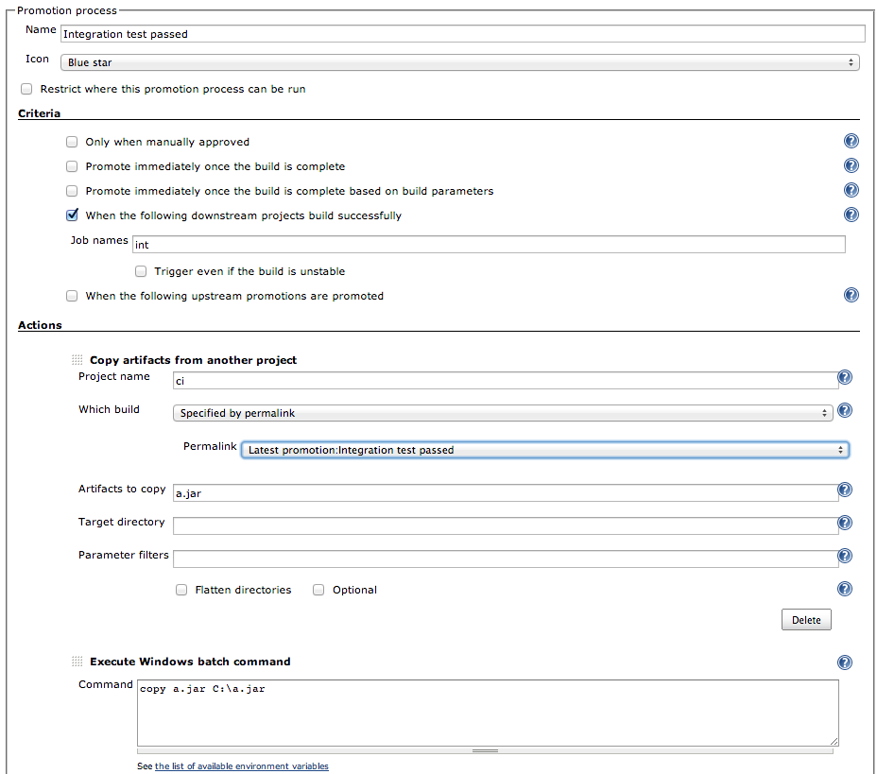

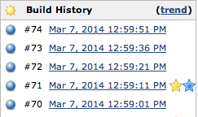Save this configuration, start another “int” build, and look at its console output to observe the promotion takes place. Go back to the build history of the CI job, and see a blue star, next to the latest build with a gold star. This verifies that the integration test job is only testing a QA-qualified build.

Step 6. Putting Everything Together

Start producing CI builds again and you can randomly manually execute the integration test and see that c:\a.jar gets updated accordingly (open this file in notepad and you see where it came from.)

Step 7. Extra Credit

If you are willing, you can tweak this setup further. Here are some of the suggestions:

* Clone the integration test job into another job, pretending that you have two independent test suites. Require that a build passes both integration tests to be promoted. Randomly induce failures in those integration tests, to simulate real integration tests. If one fails and the other succeeds, observe that you only need to rerun the failed suite and make it pass to promote the build.
* Clone the CI job into another job, pretending that you have two components independently build and QA-ed. Modify the integration test so that it downloads two components and promote them both when it is successful.
* You need not use the copy artifacts plugin to implement a promotion. Create a directory c:\depot, and pretend that this is the repository that your QA-ed build goes to. Tweak the QA promotion step and integration test definition so that the QA promotion will copy the binary here, then the integration test will pick it up from here.

# Lab 12: Parameterized builds

Goal

In this lab, you will learn how to run the integration tests in a different browser, by getting Jenkins to prompt for the browser type when you trigger the build.

Step 1. Install the Parameterized Triggers plugin

For this lab, we will be using the “Parameterized Trigger” plugin. Install this plugin and go back to the top page of Jenkins.



Step 2. Configuring the Parameterized Triggers plugin

For this lab, we will copy the gameoflife-integration-tests build job, and adapt it so that it can be triggered manually. Start by copying this build job. Next, we need to create a parameter for this build job. Tick on the ‘This build is parameterized’, and add a Choice parameter called “browser”, as shown here:

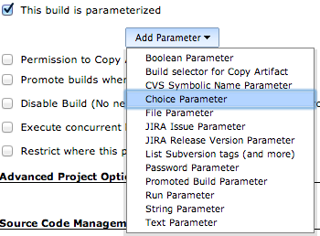

Add ‘firefox’, ‘iexplorer’ and ‘htmlunit’ as choices:

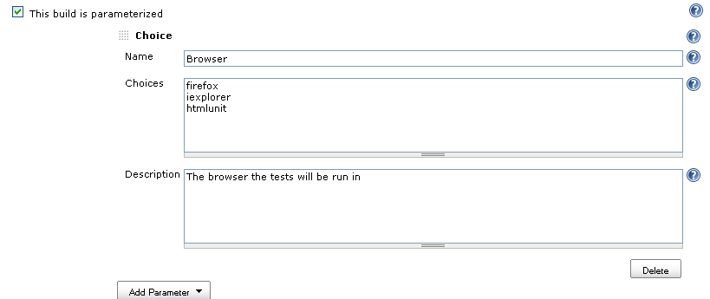

Make it a manual build by deactivating all of the build triggers.

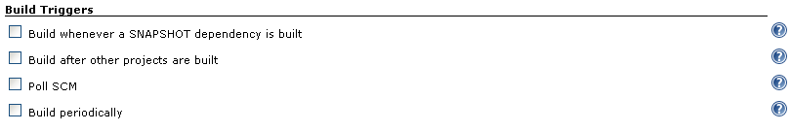

Now pass this parameter into the build as the webriver.driver property, as shown here:

clean verify -B -U -Dsurefire.useFile=false -Dwebdriver.driver=${Browser} -Dwebdriver.port=9094 -Djetty.stop.port=9996

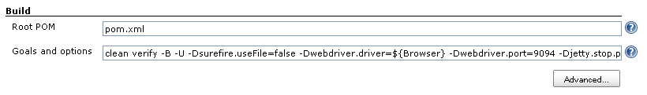

Now start this build manually. Jenkins will prompt for a browser, presenting the list of supported options in a dropdown list:

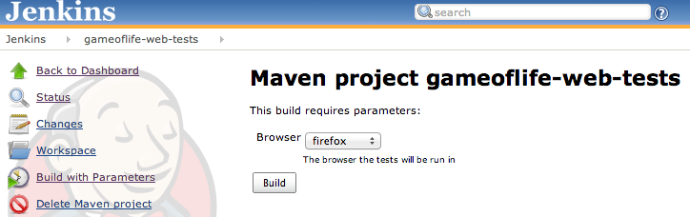

The tests should now run on the browser you chose.

# Lab 13. Automatic deployments to Tomcat

Goal

In this lab, you will learn how to automatically deploy snapshots to Tomcat.

Step 1. Install the “Deploy to container” plugin

For this lab, we will be using the ‘Deploy to container’ plugin. Install this plugin as we have in past labs (“Manage Jenkins” -> “Manage Plugins”-> “Available”):

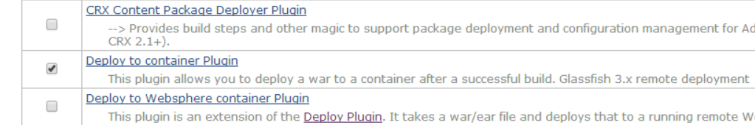

Nowgo back to the top page of Jenkins.

Step 2. Automatically deploy a SNAPSHOT web application to Tomcat

We are going to modify the gameoflife-default build job so that it automatically deploys the gameoflife web application to Tomcat after each build. There is an instance of Tomcat running on port 8888 which we will use as a test server.

Open the configuration screen of the gameoflife-default build job and go to the ‘Post-build Actions’ section. Click on the “Add a post-build action” button and then select the “Deploy war/ear to a container” option:

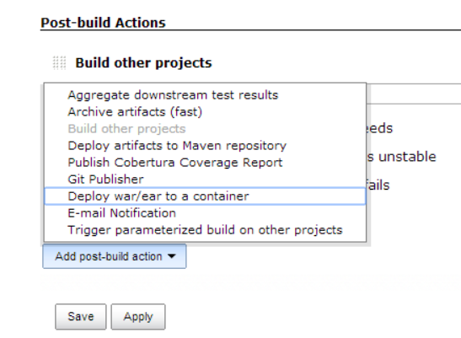

Select ‘Tomcat 6.x’ as your container and enter “**/target/*.war” in the WAR/EAR files field:

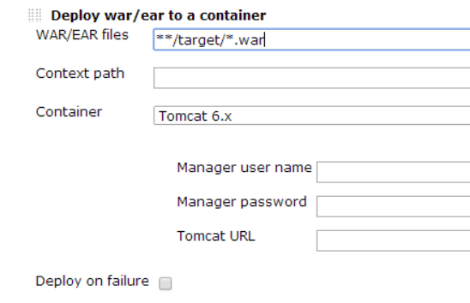

This will deploy any WAR files generated by the build, which is what we want.

Now enter the URL of the target Tomcat instance (“http://localhost:8888”) and the Tomcat manager username and password (“admin” and “password” respectively):

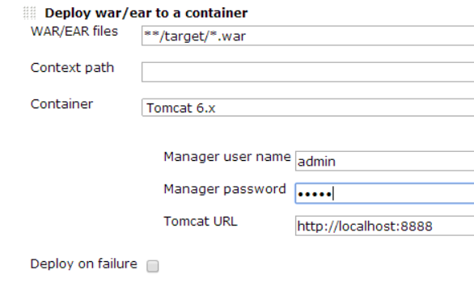

Note: if your build fails and you receive a “401” error in your console output, this is an authentication error and was likely caused by a typo in the password or username fields.

Save the build job and trigger a manual build by hitting the “Build Now” button in the left-hand menu. Now go to <http://localhost:8888/gameoflife/>to see the deployed application:

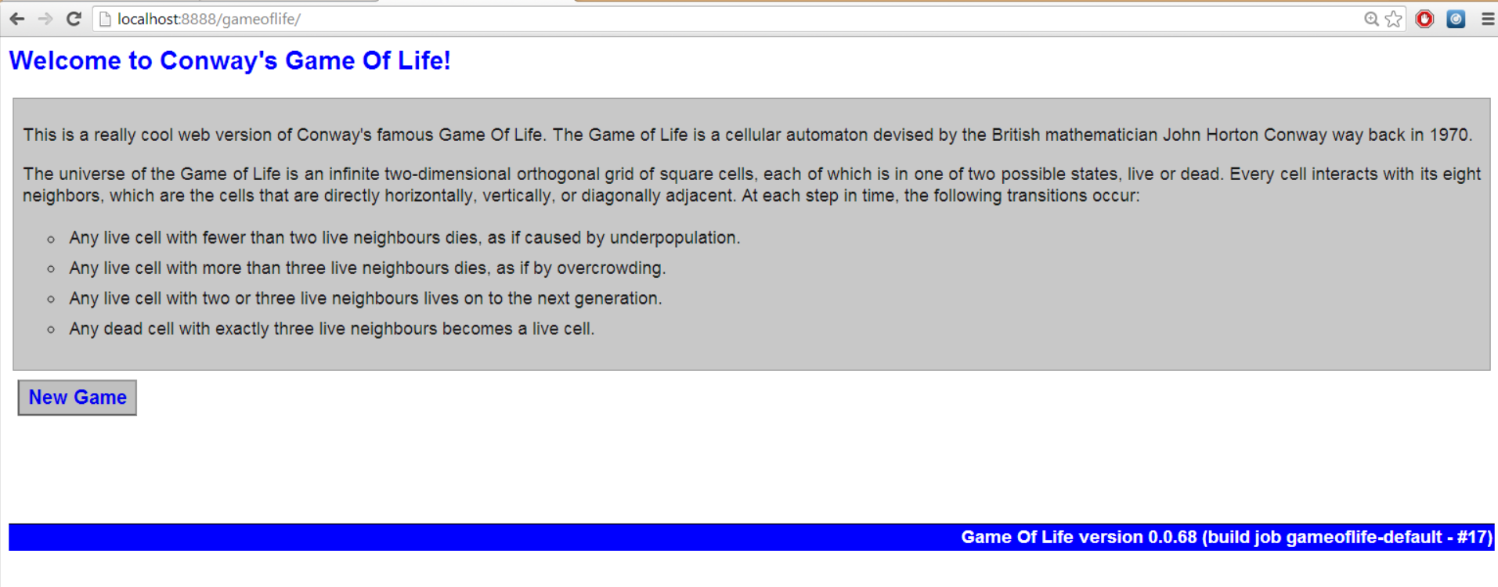

To prove that Jenkins really is deploying the latest snapshot version of the webapp, go and make some cosmetic changes to the home.jsp page.

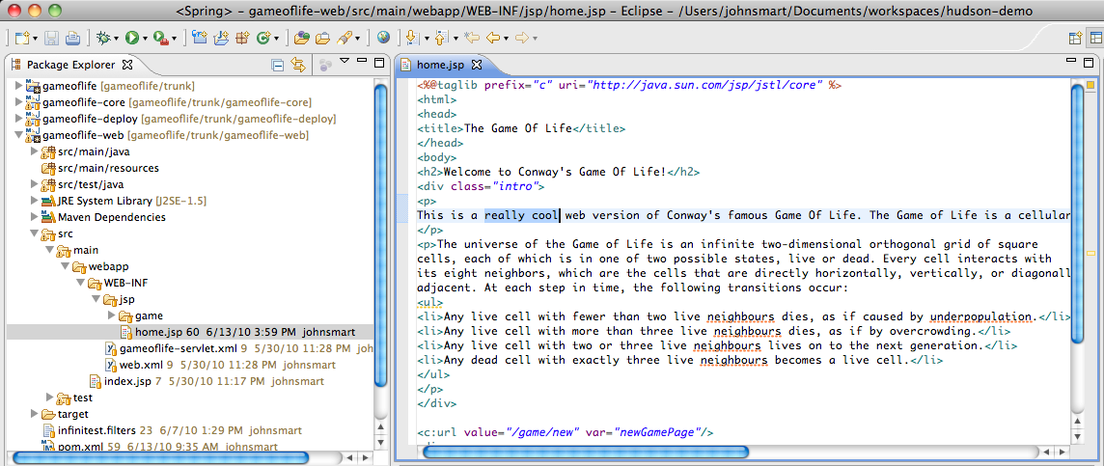

Save these changes and commit them to Subversion. Then wait for the gameoflife-default build to complete and refresh the gameoflife URL. You should now see your cosmetic changes appear.

# Lab 14: Distributed builds

Goal

The aim of this lab is to set up a Jenkins slave and run distributed builds on both the master server and the slave. We will be running the slave and the master server on the same machine, so your lab computer will be both the master and the slave.

Step 1. Setting up a slave

Go to the “Manage Jenkins → Manage Nodes” screen and add a single slave by clicking on the ‘New Node” button.

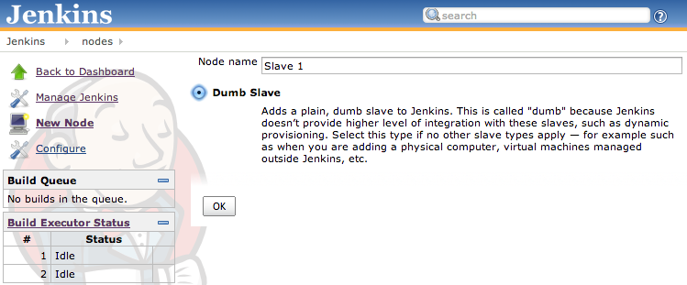

Configure this slave as shown here:

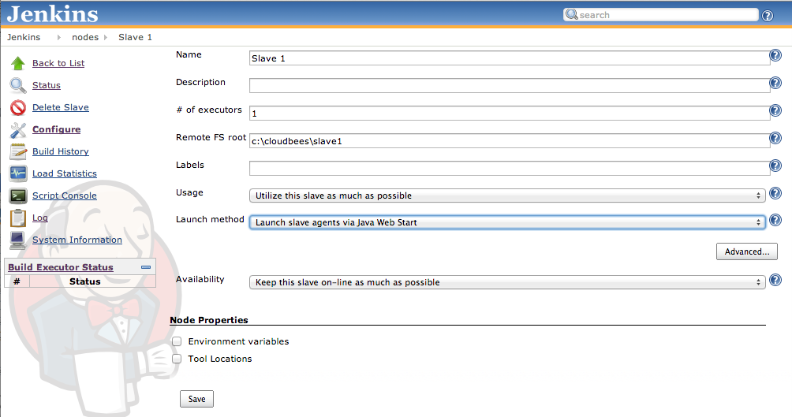

You should now see this slave in the Build Queue:

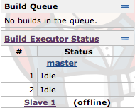

Step 2. Launching a slave

Click on the slave in the Build Queue.

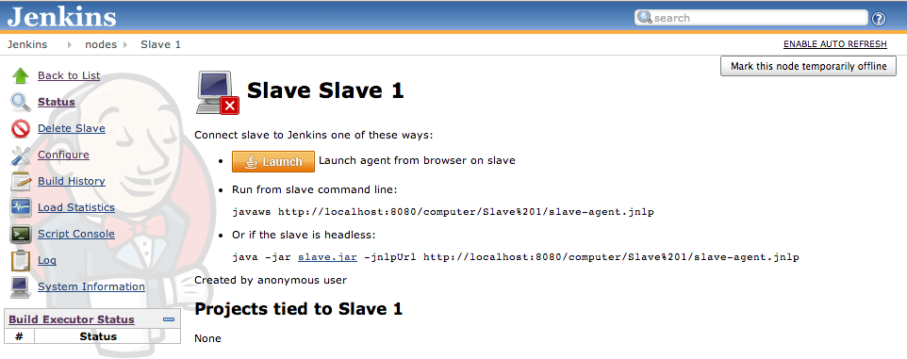

For this to work, you need to have installed the Java JRE. If this is not the case, do so now using the installer provided.

Click on the “Launch icon” to start the slave agent. Step through the dialogs until the Jenkins slave agent console appears.

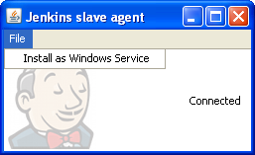

Step 3. Performing builds

Your Jenkins slave agent is now running. To test the distributed build process, go to the Jenkins home page and build all three build jobs in quick succession. At least one build should be delegated to the slave agent.

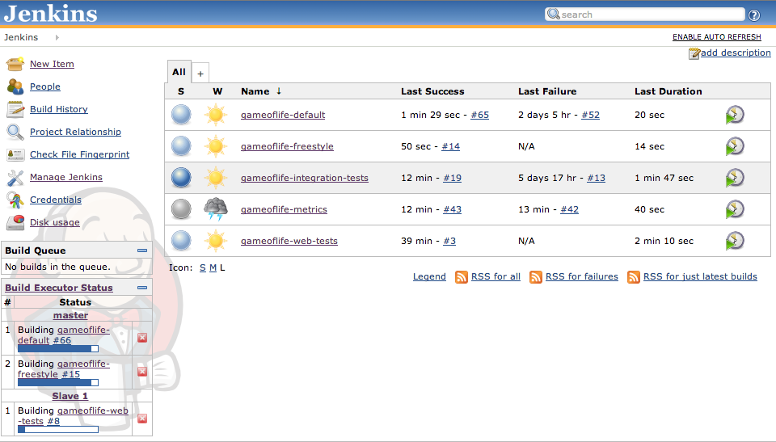

# Lab 15. Creating a folder

Goal

The aim of this lab exercise is to create a folder with a job.

Step 1. Create a new “folder” job

Click on the “New Job” menu item on the home page, and choose “Folder”. Call this folder as “JenkinsTraining”

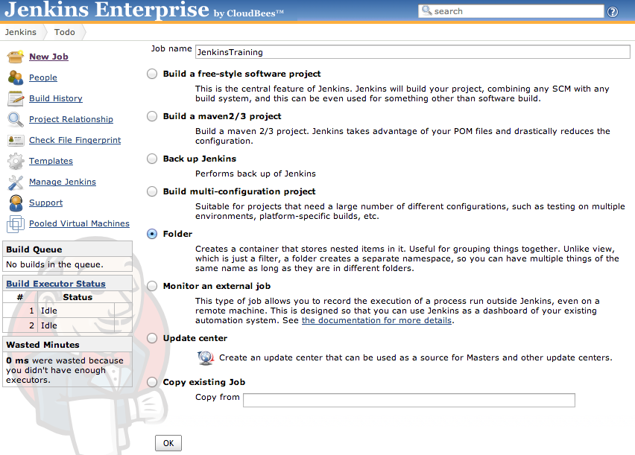

Step 2. Restrict the kinds of children in the folder

We will use this folder to only have Jenkins backup jobs. Click the “Restrict the kind of children in this folder” and select “Back up Jenkins”. Now click “Save” to complete the setting.

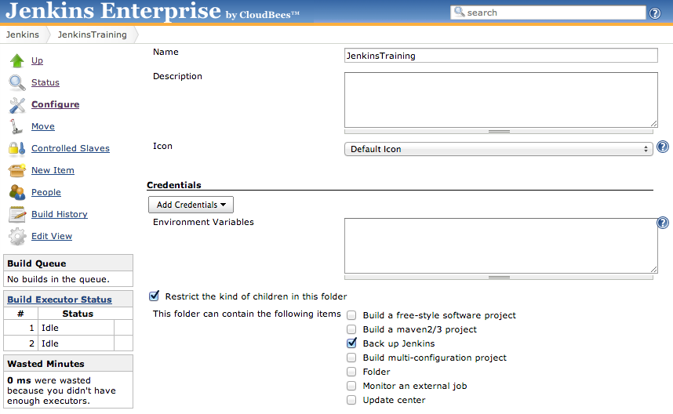

Step 3. Add a job to the folder

Click on the “New back up Jenkins” menu item on the folder top page, and choose “Back up Jenkins”. Call this job as “daily”, to indicate that this is a daily backup job. Click the “Add Build step” button and select “Take backup”.

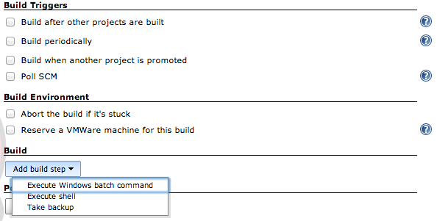

Step 4. Configure a backup job

Select “Job configurations” and “System configuration” in the “What to backup?” field.Select “Local directory” and enter c:\backups as directory to back up to. Select “keep last N backups” and set the value to 10.

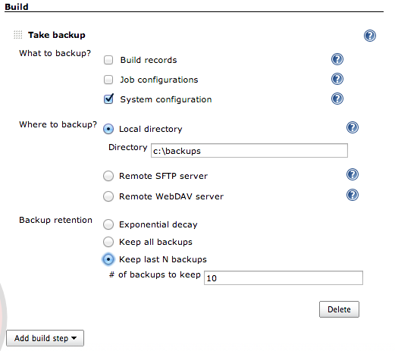

Click “Save” to send this configuration to Jenkins.

If this was a real daily backup job, we’d also set the “Build periodically” field to have this run every day. But we can’t wait for another day, so we can click “Build Now” to see the backup.

Use Windows explorer to visit c:\backups to verify that the backup was actually created.

# Lab 16. Role-Based Access Control

Goal

In this lab, you will learn how to configure the RBAC plugin for a typical security model.

Step 1. Configure Jenkins Security Realm

Before we can enable the RBAC plugin, we need to configure the security realm that will provide the user authentication. For the purposes of this lab we will use Jenkins’ own user database. There are some limitations with this security realm: for instance, it does not provide group information. Also we **need to have at least one user created before we switch over to the RBAC plugin** otherwise we will be locked out of Jenkins.

With a real deployment of Jenkins we would not be using Jenkins’ own user database, so some of the hoops we jump through for this lab exercise disappear.

Go to the Jenkins security configuration screen (“Manage Jenkins” -> “Configure Global Security”).

Make sure the“Enable security” option is checked, then scroll to the “Security Realm” section. Now select the “Jenkins’s own user database” radio button. Finally, scroll down to the Authorization section and select “Anyone can do anything”:

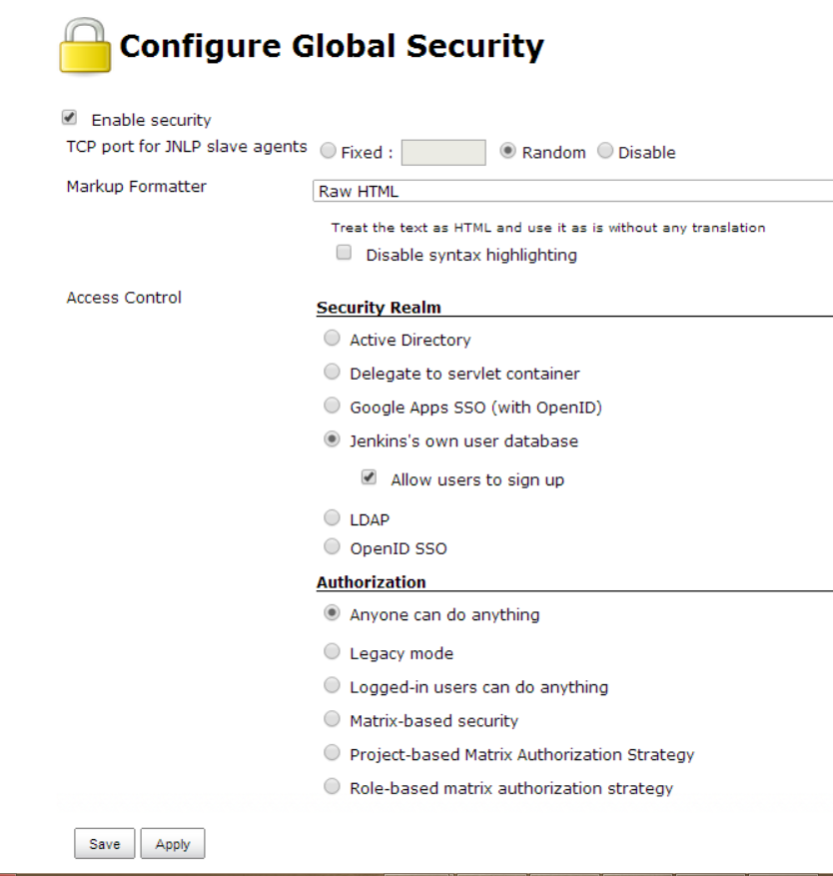

Now save your changes.

Now we are going to add three users to Jenkins’ user database. Log out of your account, then hit the “Sign up” button in the top right-hand corner of the screen:

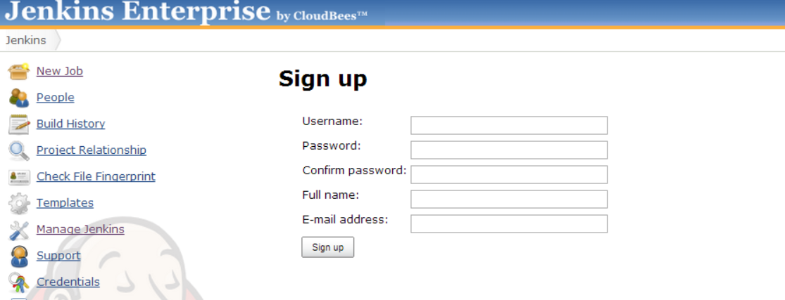

Now create three users with the following details:

|  |  |  |  |
| --- | --- | --- | --- |
|  | **User 1** | **User 2** | **User 3** |
| **Username** | harryh | barryb | sallys |
| **Password** | harryh | barryb | sallys |
| **Full name** | Harry McHarry | Barry O’Barry | Sally Somebody |
| **E-mail address** | [harry@a.a](mailto:harry@a.a) | [barry@a.a](mailto:barry@a.a) | [sally@a.a](mailto:sally@a.a) |

**Note:** You will have to log out after creating each user, before you can create the next.

Once all three users have been created, we have configured the security realm with enough information that we can safely turn on the RBAC authorization strategy without locking ourselves out.

Step 2. Configure the roles

Log in as “harryh”, the go back to the “Configure Global Security” page (“Manage Jenkins” -> “Configure Global Security”).

In the “Authorization” section, select “Role-based matrix authorization strategy” for authorization and save the changes:

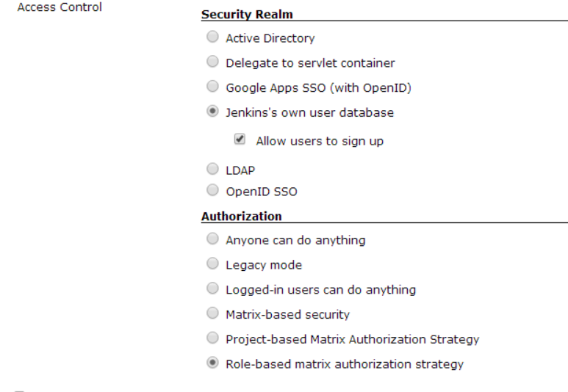

Now we’re going to assign roles to our users. First, go to the “Manage Roles” screen (“Manage Jenkins”-> “Manage Roles”). Note that if you do not see this option, you may have forgotten to save the change of Authorization strategy to “Role-based matrix authorization strategy”!

Our goal here is to create a security set up that has the following characteristics:

* Anonymous users have no access whatsoever, and they need to login first before even seeing the Jenkins top page.
* Once logged in, users have generic read access.
* Jobs can put some users to the “reader” role that has read-only access to jobs, their test results, build results, etc.
* Jobs can put some users to the “developer” role, who can start a new build, configure jobs, and so on.
* A few people will be in the “admin” role, which gets irrevocable full access to the whole of Jenkins.

This maps **to two pre-defined system roles** (“anonymous” and “authenticated”) and **three additional roles we create** (reader, developer and admin).

To create the additional roles, type in the their titles to the “Role to add” field on the “Manage Roles” page and then hit the add button:

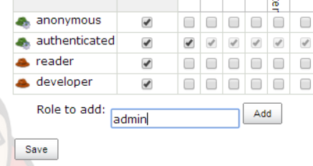

By default, “filterable” will be set to true for them all. As such, you’ll now need to edit each role’s permissions**. Note that the first permissions column shows the name of the ***section*** the permission is for, while the second column shows the name of the ***checkbox*** in that section:

|  |  |  |  |
| --- | --- | --- | --- |
| **Role** | **Permissions (section, checkbox)** | | **Filterable** |
| Anonymous | None | None | Yes |
| Authenticated | Overall | Read | Yes |
| Reader | Overall  Job | Read  Read | Yes |
| Developer | Job  Job  Job  Job  Job | Read  Create  Configure  Build  Workspace | Yes |
| Admin | Overall | Administer | No |

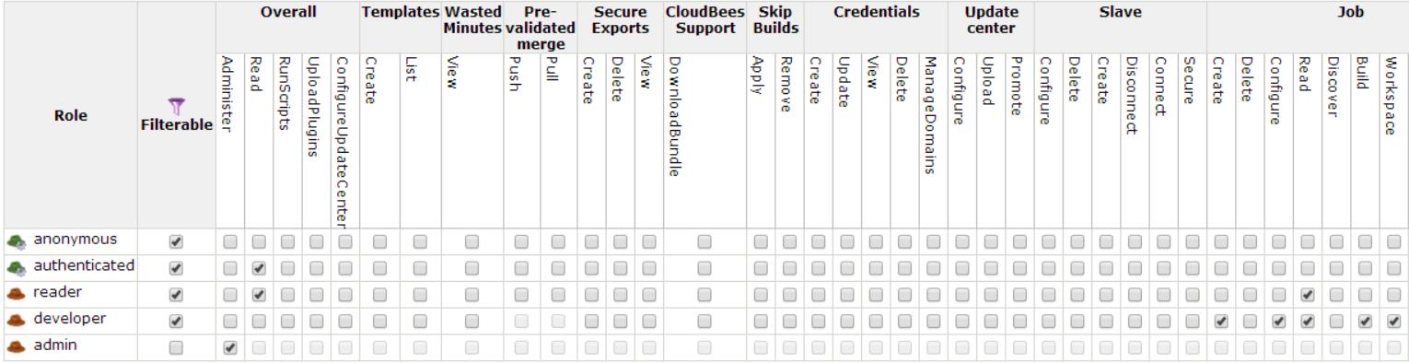Once you are ready to edit the “authenticated role”, note that you’ll be able to uncheck all boxes at once by scrolling to the right and clicking on the button.

Now try to save your configuration.

Note that the “Anti-lockout” guard will kick in and change our configuration:

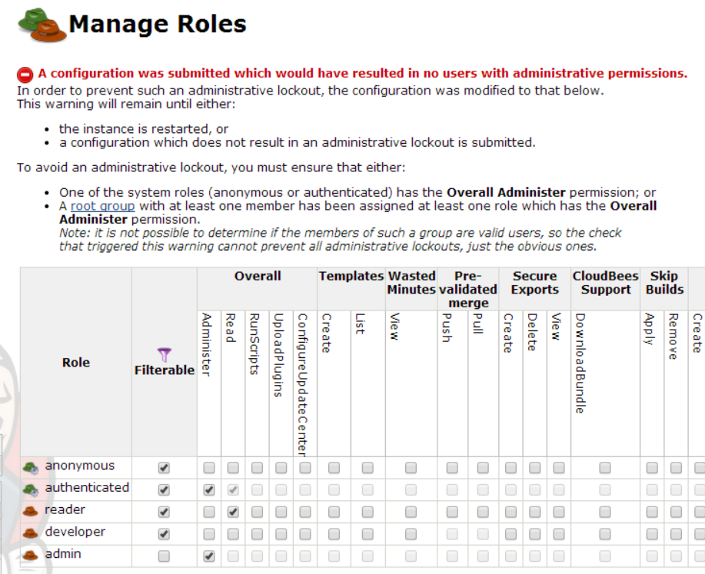

This is because the “admin”role is not associated with a groupthat contains at least one member. As such, saving the configuration as-is would have “locked” you out.

Instead, the “Anti-lockout” guard will now give the “authenticated” role overall admin permissions.

For now, let’s save thesealtered roles.

Step 3. Configure the root groups

We need the next step is to create groups that connect users to the roles, and populate these groups.

From the Jenkins top page, click on the “Groups” link in the left-hand menu. This will take you to the “Groups” list, which will be unpopulated:

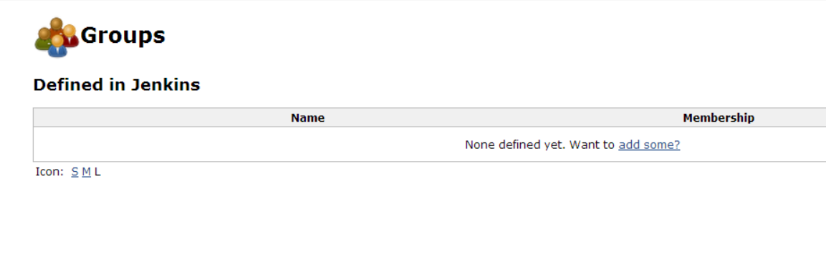

Click on the “add some?” link and start creating these three groups by populating the following fields with the following values:

|  |  |  |  |
| --- | --- | --- | --- |
| **Group Name** | **Roles** | **Propagated** | **Members** |
| Read Access | reader | Yes | barryb, harryh, sallys |
| Developers | developer | Yes | sallys |
| Administrators | admin | Yes | harryh |

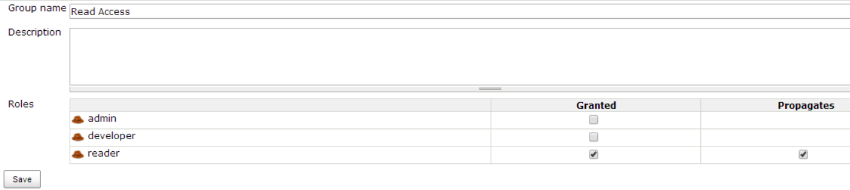For example, “Read Access” is configured like this:

Once the Group Name and Roles Granted/Propagated fields are set, hit “Save” and add the corresponding users to the group:

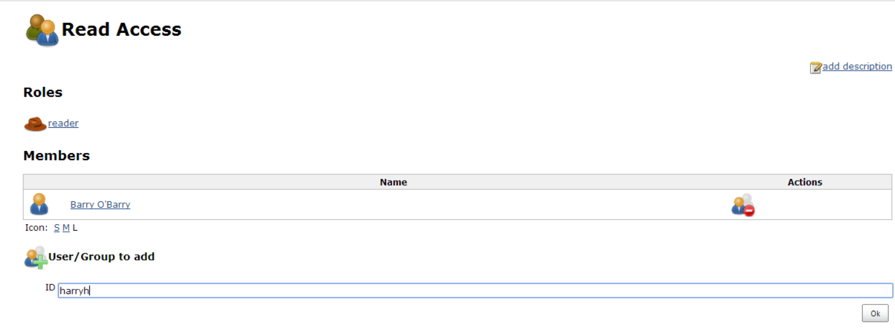

Repeat this process until all 3 groups have been created by hitting the “Back to groups” link in the left-hand menu and then hitting the “New Group” link in the same menu while on the “Groups” page.

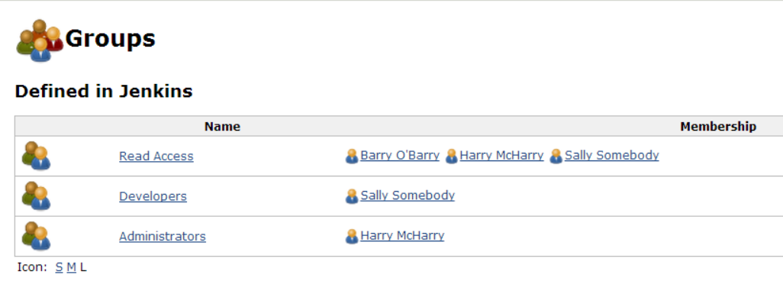

Step 4. Completing configuration of the roles

Now that we have a group with the Overall/Administer permission, we can complete configuration of the roles.

Go back to the “Manage Roles” screen (“Manage Jenkins” -> “Manage Roles”).

De-select the Overall/Admin permission for the “authenticated” role and ensure that the Overall/Read permission is still on selected.

Now save the configuration. Since the “admin” role is now associated with a populated group, you should not receive an “Anti-lockout” warning.

Step 5. Explore the permissions

Logout of Jenkins and verify that you cannot see any of the jobs in Jenkins.

Login as barryb and verify that you can see the jobs created in previous labs but you cannot trigger any builds nor modify the job configurations:

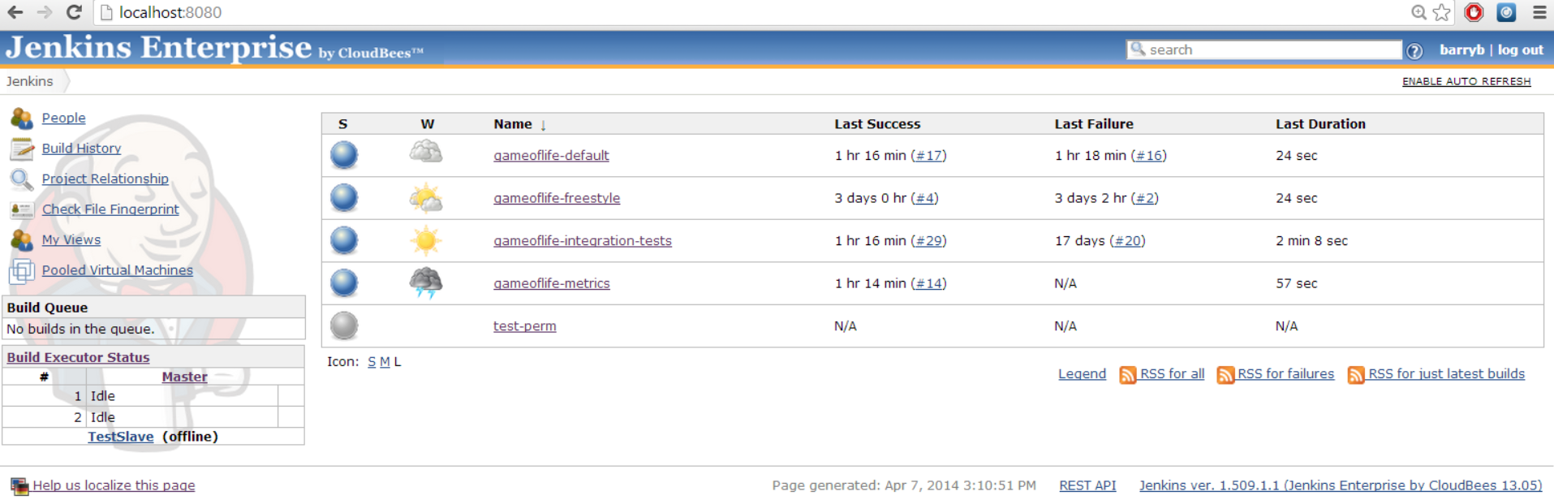

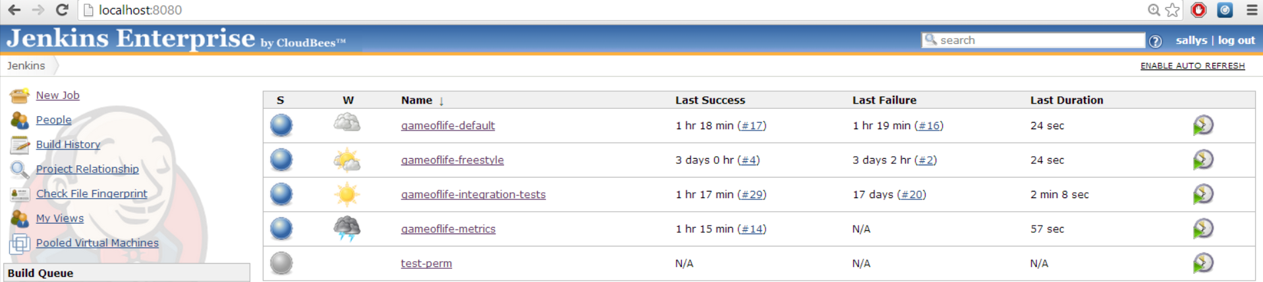Logout and login as sallys. Verify that you can create a new freestyle job and trigger a build of the job, but that you do not have access to the “Manage Jenkins” screen:

Logout and login as harryh. Verify that you can configure the job you created as sally, and that you can trigger it to build. Verify that you can access the *“*Manage Jenkins” screen:

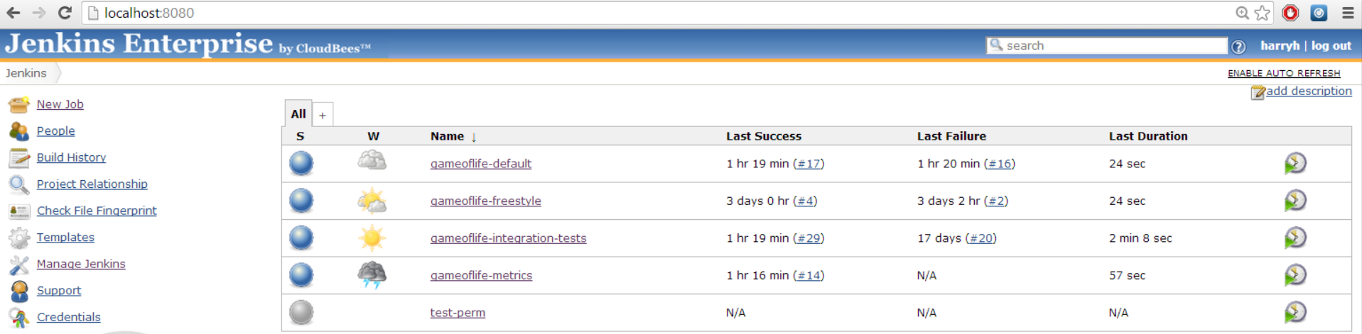

Step 6. Refine the groups

It is a little bit messy that we have added all the developers and administrators to the Read Access group as well as their respective group. It would be much better if all the members of the Developers and Administrators groups were automatically members of the Read Access group[1].

To change this, let’s go back to the Groups management screen and click on the “Read Access” group.

Add the following groups as members: “Developers” and “Administrators”:

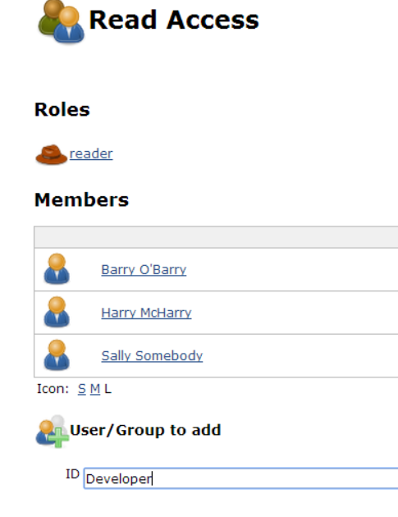

If you have spelled the names correctly they should show up with the Group icon and not the single user icon. Your screen should look something like this:

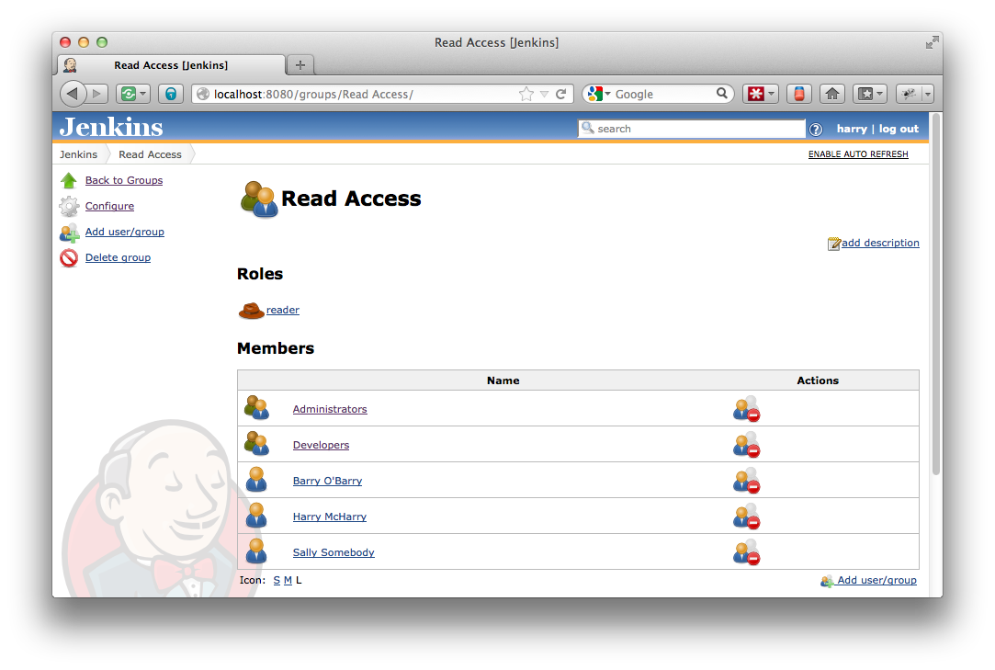

Now we can remove the Harry and Sally users from the Read Access group as they are already included by virtue of their group membership. To do this, hit the icon next to Harry and Sally’s names and hit the to confirm their removal. You should now have only “Administrators”, “Developer”, and “Barry O’Barry” listed as members of the “Read Access” group.

**Note:** if we were using a non-toy Security realm, such as Active Directory, Unix user/group database, LDAP, etc. Then the external group name could alternatively be added as a member of the group to achieve similar effects.

Step 7. Create a secret project

We will now create a secret project of which Barry will be the sole developer.

First, make sure you are logged in as harryh. Now create a new folder in the root of Jenkins called “Barry’s project” by clicking on the “New Job” link in the left-hand menu and selecting the “Folder” type for the job:

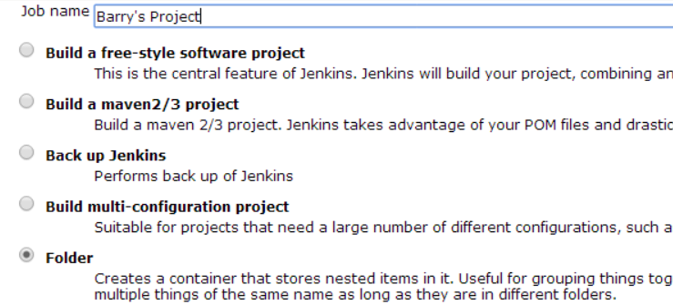

Once the folder has been created, open it up and click on the “Groups” link in the left-hand menu.

We’re going to create a new group for this folder, so hit the “New Groups” link in the left-hand menu and name it“ProjectDevelopers”.

Grant the group the “Developer” role, and on the next page add *barryb* as a member of the group:

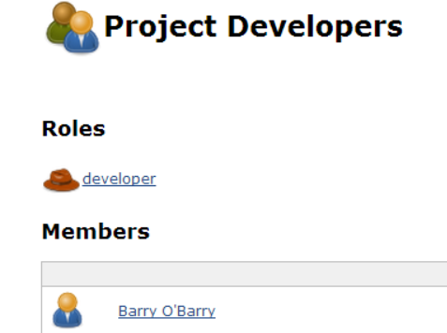

Now go back to the “Barry’s Project” folder and click on the “Roles” link in the left-hand menu, then click the “Filter” link and mark all roles as requiring explicit assignment:

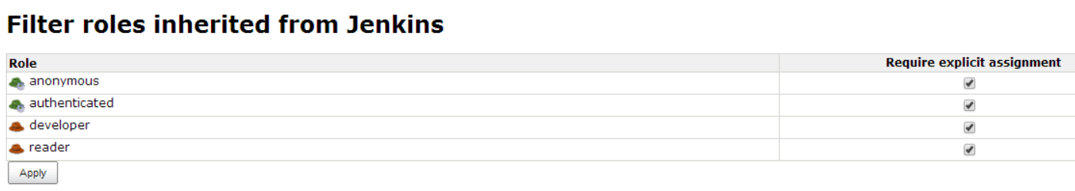

What are we doing here? Normally, permissions granted closer to the root gets inherited through to folders and jobs in them. So Sally, who has the developer role to the root, will also get the developer role in the “Barry’s project” folder.

When we check“require explicit assignment”, we are essentially saying that someone explicitly needs to be assigned this role in this folder to be able to get the role. In this way, Sally no longer has the developer role in this particular folder.

Logout and login as barryb. Verify that you can create and build jobs, but only in the Barry’s project folder.

Logout and login as sallys. Verify that you cannot see the project Barry’s project. Try to access the project directly using the URL, e.g. <http://localhost:8080/job/Barry%27s%20project/> and confirm that you get a 404 error page.

Step 8. Extra credit

Create a new ‘manager’ role with the Group/Manage; Group/View and Role/View permissions.

Create a group within the “Barry’s project” folder called “ProjectManagers”

assigned this role but pinned, and with barryb as a member.

Login as barryb and then add sallys to the ProjectDeveloper’s group. Barry will only be able to manage the existing groups directly in the Barry’s project folder. He will not be able to manage or view the groups in sub-folders or child jobs.

Verify that sallys can now see Barry’s project.

As different users visit the <http://localhost:8080/roles/whoAmI> and <http://localhost:8080/job/Barry%27s%20project/roles/whoAmI> screens to see the information reported.

As the harryh user, visit the <http://localhost:8080/job/Barry%27s%20project/roles> and <http://localhost:8080/roles> screens to see how the effective permissions are reported.

Refine the Read Access group some more by replacing the user ‘barryb’ with the system identity ‘authenticated’.

Open the Read Access out to everyone by adding the other system identity ‘anonymous’ to the Read Access group. Note that Barry’s project is still as secret as Barry configured it to be.

# Lab 17. Validated merge

Goal

In this lab, you will learn how to set up Jenkins for validated merge with Git as an administrator, then how to perform actual validated merge as a developer.

Step 1. Administrator Setup

Jenkins offers two transports for Git, HTTP and SSH. In this lab, we’ll use SSH because it supports password-free yet secure authentication mechanism.

First, go to the system configuration screen (<http://localhost:8080/configure>), and look for the “SSH Server” section. By default, Jenkins uses a random available port to listen on inbound SSH connection, but with developers actively using validated merges, you should fix the port to make sure that the port number doesn’t change over time.

Any number will be fine, but most likely the default SSH port (22) is used by the real SSH daemon, we’ll pick something else, like 2222.

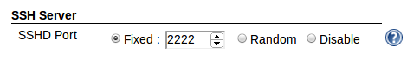

Also, verify that the “Security Realm” configuration is set to “Jenkins’ own user database”, and that you’ve created the administrator “harryh” user. If you have completed the “role based access control” lab exercise, this is how it should be set by now.

Next, we need to configure the git plugin since this is the first time we use it. Look for the “Git” section in this page, then type in “c:\cygwin\bin\git.exe” to point to our Cygwin version of Git.

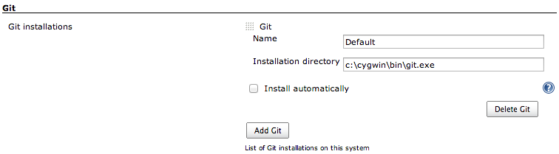

Click “Save” to apply these settings. This is the only thing that the administrator of Jenkins has to do.

Step 2. Setup a Jenkins job for CI build & validated merge

Let’s pretend that you are a team lead and set up a Jenkins job that does validated merge. Go to the Jenkins top page, click on the “New Job” menu item, and choose “Build a free-style software project”. Call this project ‘gameoflife-personal and click OK.

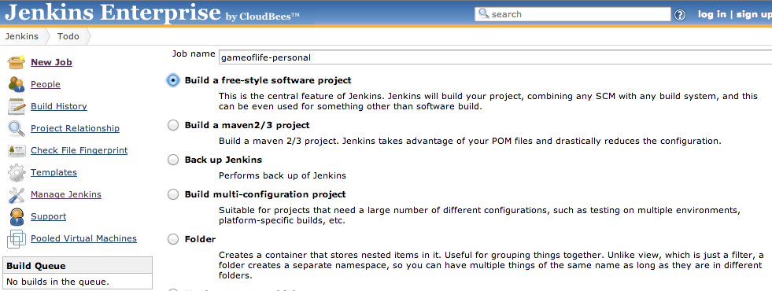

In the job configuration screen, select “Enable Git validated merge support” to enable the feature. Click “Advanced”, and type in the alternate push URL as “c:\cloudbees\labs\repo.git”. Select Git as the source code management, and specify /cygdrive/c/CloudBees/labs/repo.git as the repository URL.

Git plugin uses the git binary from Cygwin to check out, and it wants Cygwin-style path. In the meantime, the validated merge support uses JGit, which uses Windows style path. This is why we have to specify alternate push URL that’s different from the checkout URL.

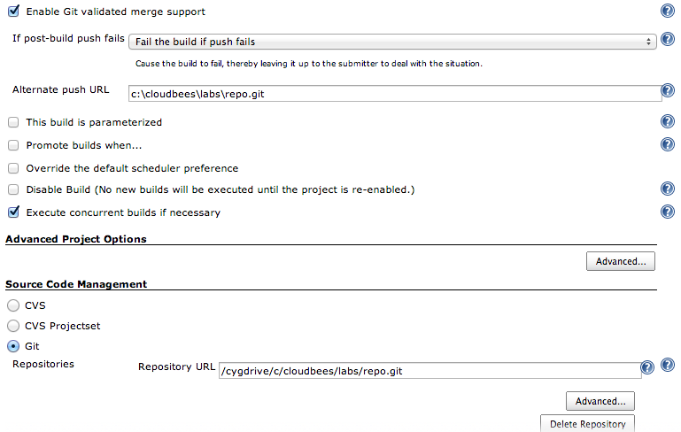

In the main build section of the configuration page, add “Invoke top-level Maven targets” and then type in “install” as the goal.

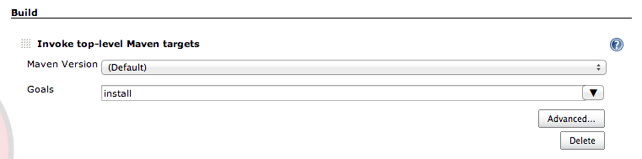

Click the “Save” button to apply this configuration. If you’d like, you can click “Build Now” to make sure this set up is correct.

That completes the team lead’s work.

Step 3. Developer Setup 1 (ssh key generation)

Now pretend that you are a developer, and let’s setup SSH public key (unless you already have a key pair, in which case don’t generate a new key pair and use your existing key pair.)

First, we’ll generate the SSH key pair. Launch Cygwin, and executessh-keygen. For simplicity, accept the default location and set no passphrase.

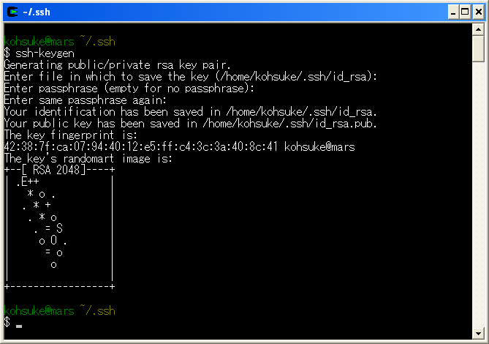

Next, copy the generated SSH public key into clipboard by executing notepad $(cygpath -w ~/.ssh/id_rsa.pub) and then copy the whole text into clipboard.

Column: SSH Public Key Authentication Crash Course

In SSH, the preferred method of authentication is called “public key authentication.” This relies on a pair of big sequences of bits called private key and public key. A user keeps the private key for himself, and typically stores this in ~/.ssh/id_rsa (RSA is the name of the algorithm.) The public key isn’t secret, and it needs to be pre-registered to servers that he wishes to connect to.

When a connection is attempted, the SSH protocol performs cryptographic challenge-response hand-shakes so that the server can verify that the client actually possesses the private key, but in such a way that the server doesn’t see the actual private key itself.

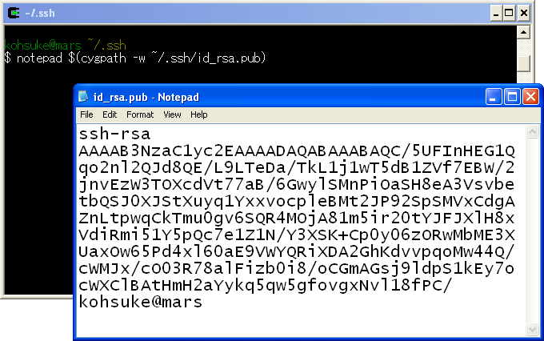

Step 4. Developer Setup 2 (ssh key registration)

Login as harryh, then click your name on the top right corner of the page, then click the “Configure” link from the left. Paste the public key into the “SSH Public Keys” section.

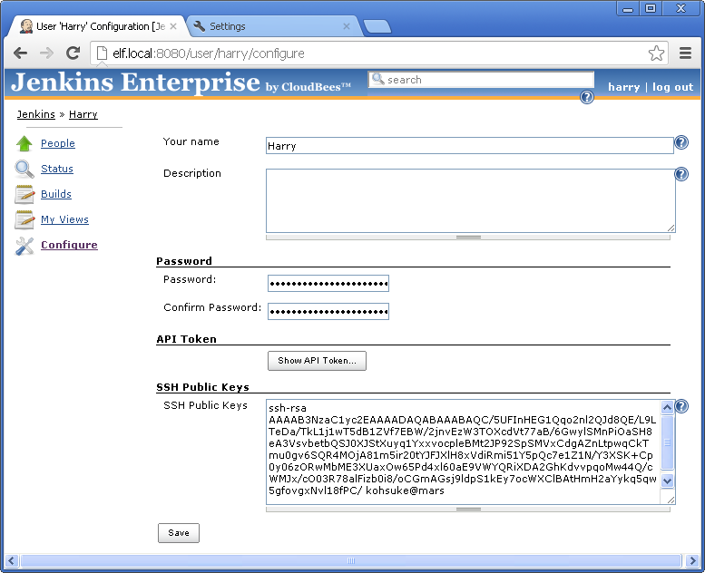

Click “Save” to apply this change. Now you are ready to use this feature.

Step 5. Edit the code and test the change

As a developer, let’s make changes to the source code. First, clone the team repository by issuing the following command from Cygwin shell:

$ cd /tmp  
$ git clone /cygdrive/c/CloudBees/labs/repo.git harryh  
$ cd harry

Let’s play a scenario where a developer unknowingly breaking a build by a change. Any chance would do, but for example, edit gameoflife-core/src/main/java/com/wakaleo/gameoflife/domain/Cell.java and make it uncompilable by adding garbage (say “!!!”) at the top of the file.

Commit this change as follows. Note that because Git is distributed, at this point this change is not exposed to the team repository yet.

$ git commit -am "added a new feature"

To have this change tested by Jenkins, click the “Git repository for validated merge” menu item from the “gameoflife-personal” project page, then click the clipboard icon on the right to copy the command line that needs to be executed.

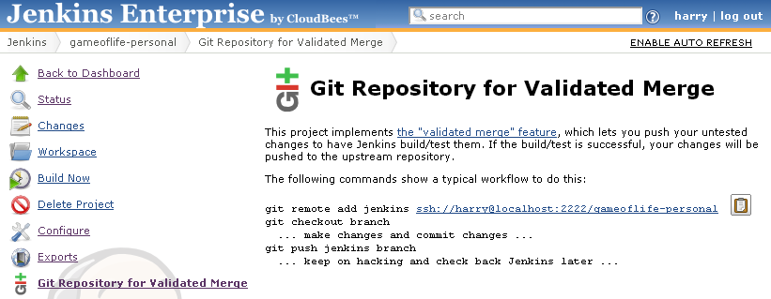

Go back to the Cygwin console and execute this command (as a single line):

$ git remote add jenkins  
 ssh://harryh@localhost:2222/gameoflife-personal

This will register Jenkins as one of the upstream repository.

Next, run the git push command to send the result to Jenkins.

$ git push jenkins master

Switch back to Jenkins and wait for the build to take place. Look around in the Jenkins UI to make sure that:

* Change log correctly reports your personal change
* Build has actually picked up your change
* UI in the build top page that shows how others can retrieve this change.

Step 6. Verify isolation

Let’s now pretend that you are another developer in the team, Sally, and makes sure she is isolated from the regression that we just made in the previous step. Open another Cygwin console, and move to another directory and check out a separate workspace:

$ cd /tmp  
$ git clone /cygdrive/c/CloudBees/labs/repo.git sallys  
$ cd sally

Run “git log” to verify that Sally doesn’t yet see the regression from Harry.

Step 7 (optional). Sally makes independent changes

This step is optional and you can skip it if you feel you are behind.

To make this lab more realistic, where many developers are making changes simultaneously, let’s have Sally make changes, and push it.

Let’s make some minor edits in pom.xml (add some empty new lines somewhere for example), and send it straight to the team repository, bypassing Jenkins.

$ cd /tmp/sallys  
$ vi pom.xml  
$ git commit -am "Sally made some changes"  
$ git push origin master

Step 8 (optional). Sally picks up where Harry left off

This step is optional and you can skip it if you feel you are behind.

In step 5, Harry learned that his change didn’t pass the bar, and he now wants Sally to look at what he’s working on to get her advice. So let’s pretend to be Sally, fetch Harry’s changes.

Go to the build that Harry started and failed in the Jenkins UI. The top page of the build has the git command written in it, which explains how someone else can fetch this change into his/her workspace.

Click the clipboard icon on the right of this command and paste that in the command line in Sally’s workspace

$ cd /tmp/sallys  
$ git fetch –n ssh://harryh@localhost:2222/gameoflife-personal tag changes/4

This creates the tag named “changes/4” in Sally’s workspace. As Sally, you can check out this tag, make follow-up changes, and push it again back to Jenkins.

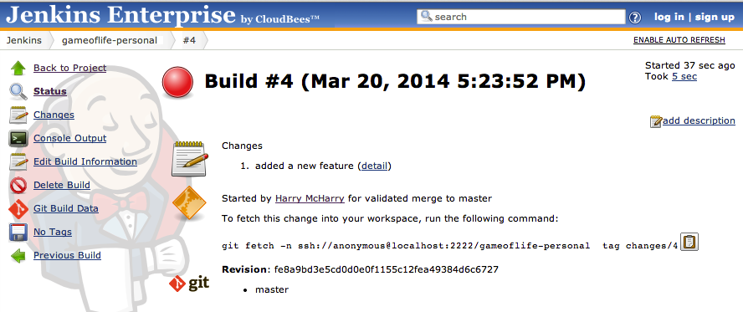

Step 9. Harry fixes the regression

Let’s go back to Harry, and fixes the regression (by removing whatever change you introduced in earlier step).

$ cd /tmp/harryh  
$ vi …  
$ git commit -a -m "fixed the regression"

If you know Git, you can amend the existing commit instead of adding a separate commit.

Next, Harry will send this change to Jenkins again.

$ git push jenkins master

Switch back to Jenkins and wait for the build to take place and succeed. Look around in the Jenkins UI to make sure that it reported the changes correctly.

Step 10. Sally sees Harry’s change

Now that the change from Harry has successfully validated and pushed to the team repository, go back to Sally’s workspace and verify that she now sees the change made by Harry.

$ cd /tmp/sallys  
$ git pull origin master  
$ git log

The log should include the changes made by Harry.

If you did step 7, you should see the merge commit between Harry’s change and Sally’s change. In this case, also verify in the Jenkins UI that it is the merge commit that was validated, not just Harry’s changes. In this way, if there were any unexpected interactions between Harry’s change and Sally’s change, the validated merge would have caught it.

# Lab 18. Builder template

Goal

In this lab, you’ll learn how to create a builder template.

Step 1. Create a builder template

First, we’ll create a builder template. When executed, this builder template produces a text file in the workspace that lists all the changes that went into this build.

Click the “Templates” link from “Jenkins” in the breadcrumb. Click “New Template”, select “Builder Template”, and enter the name“Save Changes”. Click “OK” to create a new empty builder template.

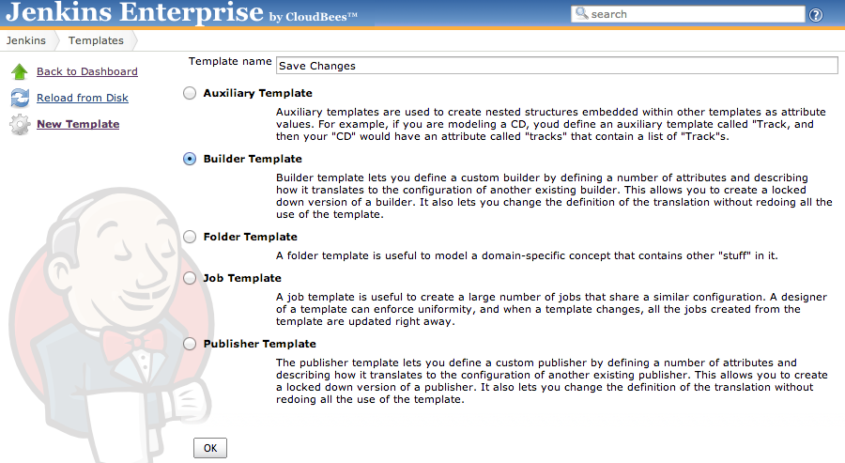

You are now in the template configuration page. Click “Add Attribute”, enter the ID “changelog” and the display name “Change Log File”. Make sure “Sets some variables using Groovy…” is selected (should be by default). For Groovy Script enter the following:

build.workspace.child(changelog).  
write(build.changeSet.items*.msg.join('\r\n'), null)

Click the “Windows Batch Script?” checkbox,and set the “Shell/Batch Script” field as follows, so that the build console will indicate where the file was written to.

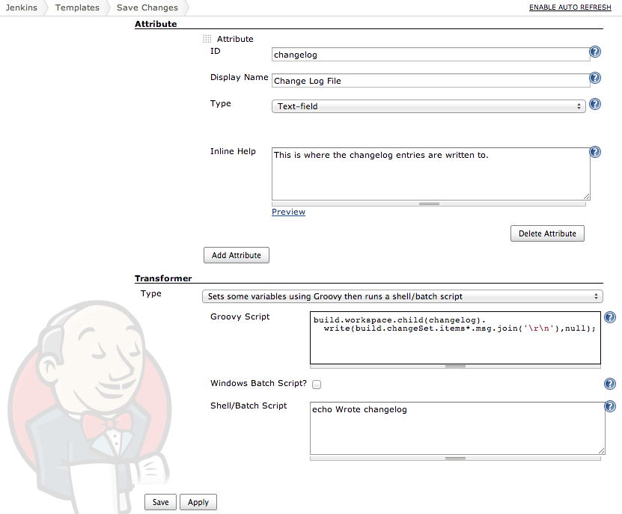

Click “Save” to complete the setup of this template.

Column: How did you come up with that Groovy script?

The “build” variable refers to the instance of the AbstractBuild class that represents currently in progress (for other exposed variables, see the “Variable Bindings” section in [http://jenkins-enterprise.cloudbees.com](http://jenkins-enterprise.cloudbees.com/). For methods of AbstractBuild, see <http://javadoc.jenkins-ci.org/byShortName/AbstractBuild>.

Step 2. Use a builder template

Open the “gameoflife-freestyle” project from Lab 2, and thenclick the “Configure” link from the left.

Turn off “Poll SCM” because we want to make several commits to before firing a new build to test our new builder template, and polling might automatically start a new build when we don’t want one.

Click “Add build step”, then select “Save Changes” to insert a new build step. Enter “changes.txt” for the “Change Log File” field. Grab the “Save Changes” header of this build step, then drag this to the top of the “Build” section.

Click “Add post-build action”, select “Archive artifacts using an rsync-inspired algorithm”, and enter “changes.txt” for the “Files to archive” field. This lets us see the generated changelog file from Jenkins web UI.

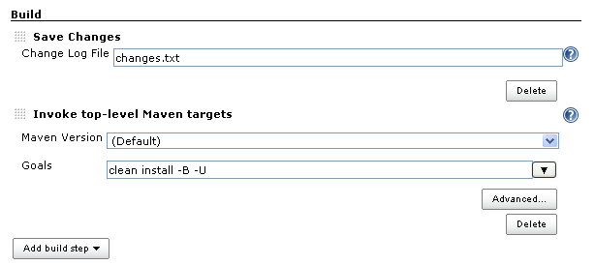

Click “Save” to apply this configuration to Jenkins.

Step 3. See the builder in action

Now open Eclipse, make some edit to any file in this project (e.g. add some spaces or add a comment to pom.xml), right-click editor window, “Team » Commit…” and enter some log message and click OK to commit. (If prompted, use harry as both the username and password.) Do this again to make a second commit (or more), but make sure to use different commit messages so that we can tell them apart!

Click “Build Now” in the Jenkins project to schedule a build. When it has finished, click on the newlycompleted build. “Build Artifacts” should list changes.txt. Click this link and you should see your commit messages. (Use the Back button to return to Jenkins.)

# Lab 19. Job template

Goal

In this lab, you will learn how to create a job template.

Step 1. Create a job template

Now we will turn the “gameoflife-freestyle” project into a job template. Browse to this project and append config.xml to the URL in the browser’s address bar; you should see <http://localhost:8080/job/gameoflife-freestyle/config.xml>

Next, copy this entire XML into clipboard. Exactly how you do this depends on the browser, but for example in Firefox, type Ctrl+U to open the source view, then Ctrl+A followed by Ctrl+C to copy.

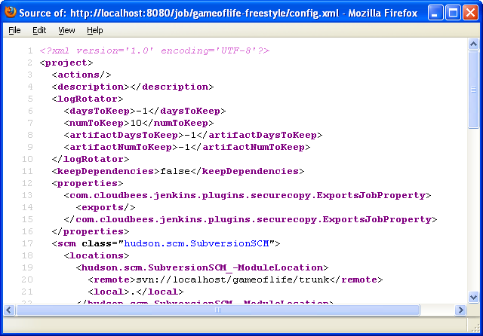

Select “New Template” and then “Job Template” and give it the name “Our Maven Project”. Click “OK” to create a new empty job template.

Select “Groovy template transformation” and paste the XML into the “Script” field. Be sure there is no blank space before thestart of the XML text, because the syntax of XML forbids that. You can drag the thick bar at the bottom of the text area down to see more than a few lines of the script at once.

Step 2. Define attributes

Let’s define some attributes.

Click “Add Attribute” and specify the ID “svnLocation” and the display name “Subversion Checkout Location”. We’ll use this to let users specify where to check out the source code.

Add another attribute, call it “properties”, and set its display name to “Extra Maven Properties”. Set the type to “Text area”. We’ll use this to allow users to specify extra Maven properties.

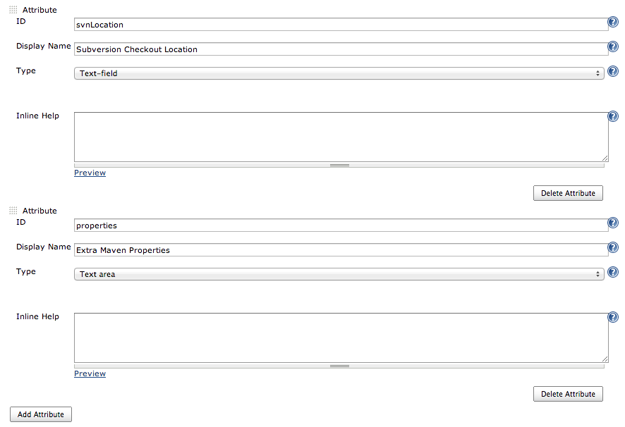

Next, we’ll tweak the transformer to use these attributes. Select the “Jelly-based transformation” as the transformer.

Look for svn://localhost/gameoflife/trunkand replace this with${svnLocation}. Then do the same withwebdriver.port=9091<linebreak>jetty.stop.port=9998 (but not surefire.useFile=false) with ${properties}

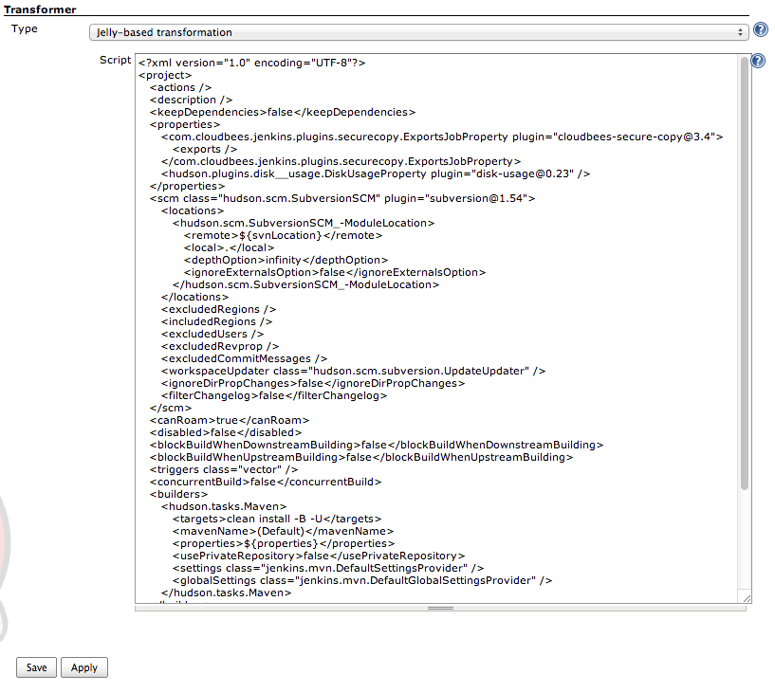

Finally, click “Save” to define this new job template.

Step 3. Instantiate this template

From the breadcrumb menu, select “Jenkins”, click “New Job” and select “Our Maven Project”. Name it “gameoflife-freestyle-templatized”, then click “OK” to create a new job.

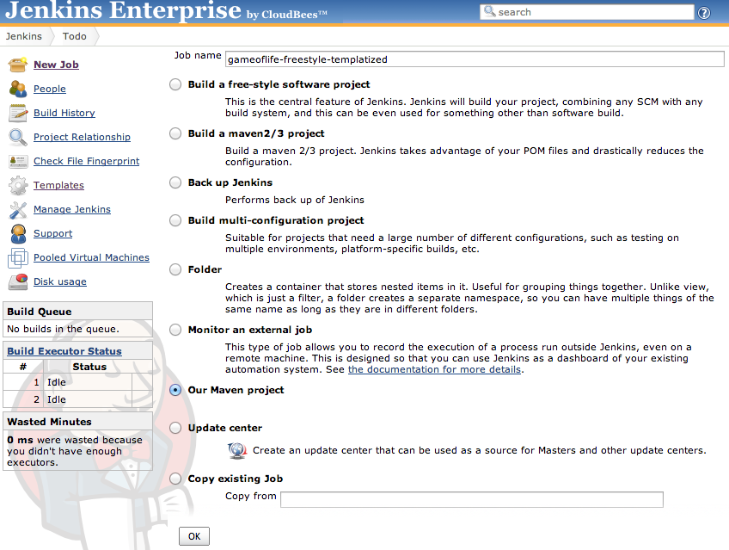

You should be now taken to the job configuration page.

For “Subversion Checkout Location”, enter svn://localhost/gameoflife/trunk and for “Extra Maven Properties”

enterwebdriver.port=9091andjetty.stop.port=9998in two lines.

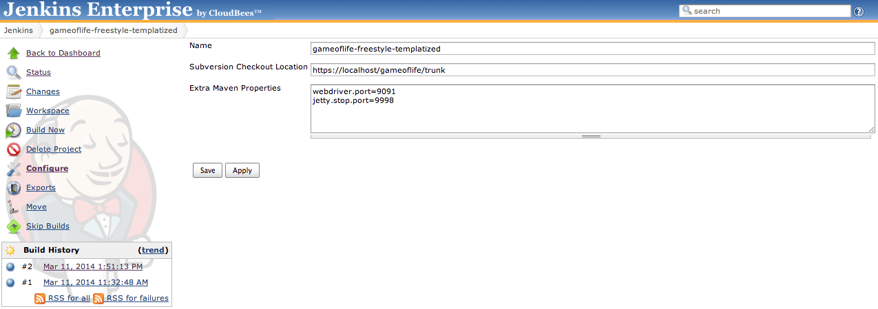

Click “Save” to complete changes.

If you now look at <http://localhost:8080/job/gameoflife-freestyle-templatized/config.xml>, you should see very similar content that you saw earlier, except for a <com.cloudbees.hudson.plugins.modeling.impl.jobTemplate.JobPropertyImpl> with attribute properties for the instance.

Click “Build Now” and you should see similar results as when building the original job.

Step 4. Extra Credit

To verify that the template is a template and not just a wizard that creates a job, let’s update the definition of this job template and make sure it gets reflected right away.

Go back to the template definition, and look for clean install -B -U in the “Script” field. This is how we invoke Maven. Change this to install -B -U by removing clean, then save this configuration.

Go back to the gameoflife-freestyle-templatized job. Without touching the configuration, simply click the “Build Now” link to start a new build, then observe that the build runs without the clean goal in Maven now.

# Lab 20. Auxiliary template

Goal

In this lab, we will play with the auxiliary template to learn how it helps building more complex template.

For this, let’s create a builder that looks for matches to regular expressions in the build console output, with the ability to combine those matches. For example, we’d like to be able to say “look for Foo:ERROR in the console output but only when there’s target/foo.log”

Step 1. Create matchers

First, we’ll create the base auxiliary template. Create a new “Auxiliary Template” named “Boolean Condition”. In the configuration screen, uncheck “Instantiable”, because this template is meant to serve as the base type of other templates. Click “Save” to finish the configuration.

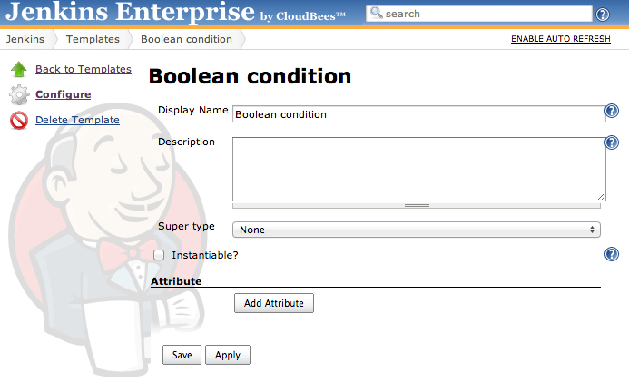

Now, let’s create another auxiliary template that represents the log matcher.Create an auxiliary template named “Log Match” with the “super type” field set to the newly created “Boolean Condition”, and add an attribute “regex” with display name “Regular Expression”. Click “Save” to finish creating this template.

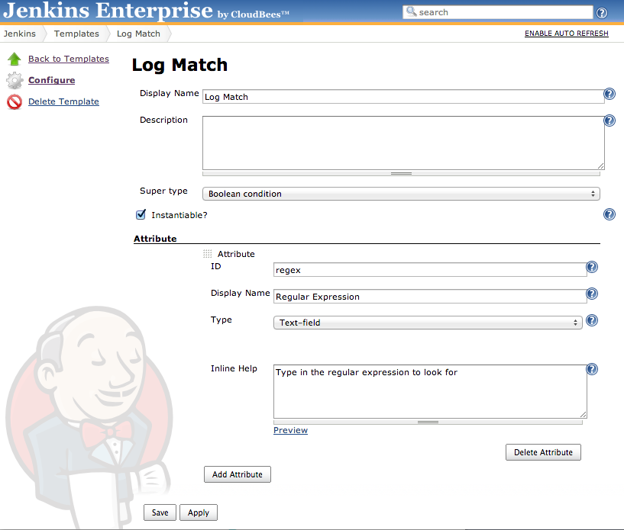

Similarly, create another auxiliary template called “File Presence”, set the super type again to “Boolean Condition”, and add the “file” attribute whose display name is “File Path”.

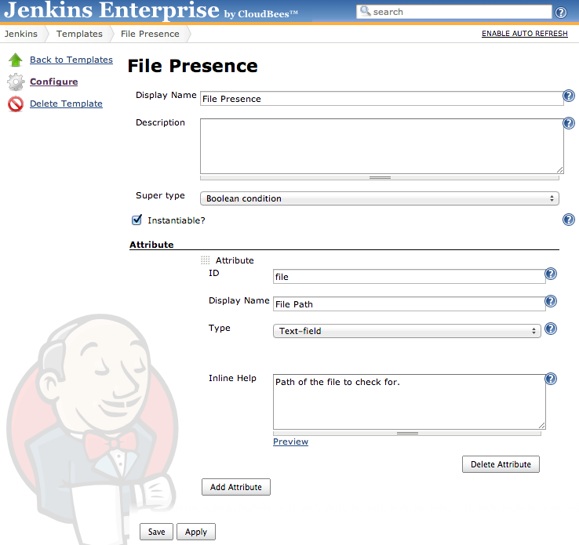

Step 2. Create combiners

We have templates that act as the terminals, so let’s create combiners that aggregate those in a Boolean expression.

Create an auxiliary template and name it “Or”, setting the “Super type” field to “Boolean Condition” template, and add an attribute whose ID is “clauses” and display name is “Clauses”. Set the type to “Nested auxiliary models”.The “Nested Model” field should be set to “Boolean Condition” and “UI mode” set to “List of values, including all the subtypes…”

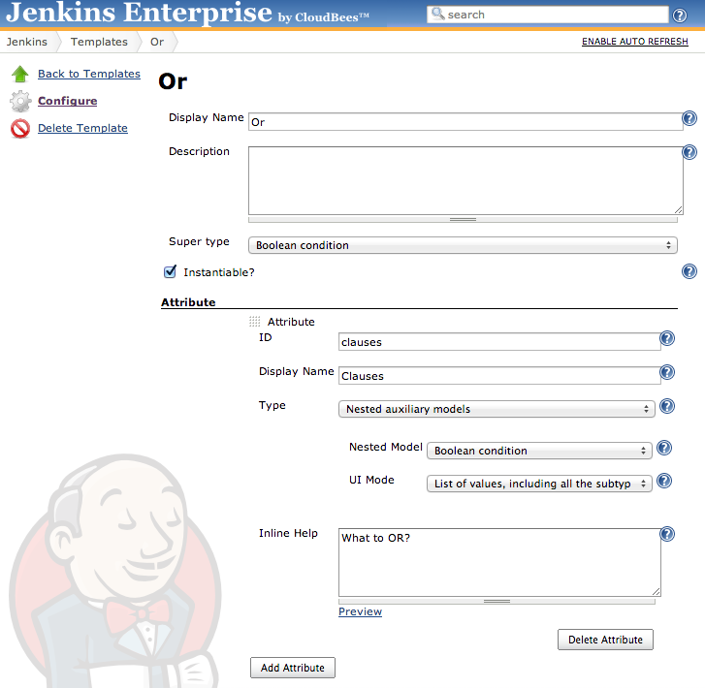

Click “Save” to finish the configuration.

Create templates AndandNand exactly the same way. (Currently cannot create Not like this—known bug.)

Step 3. Using this from a builder template

Now that our boolean expression modelling is complete, let’s create a builder template so that we can use this as a build step.

Go back to the new template UI and make a “Builder Template” named “Check Conditions”. Add an “condition” attribute whose display name is “Condition”, whose type is “Nested auxiliary models” with model “Boolean Condition” in mode “Single value (choice of all the subtypes…)”.

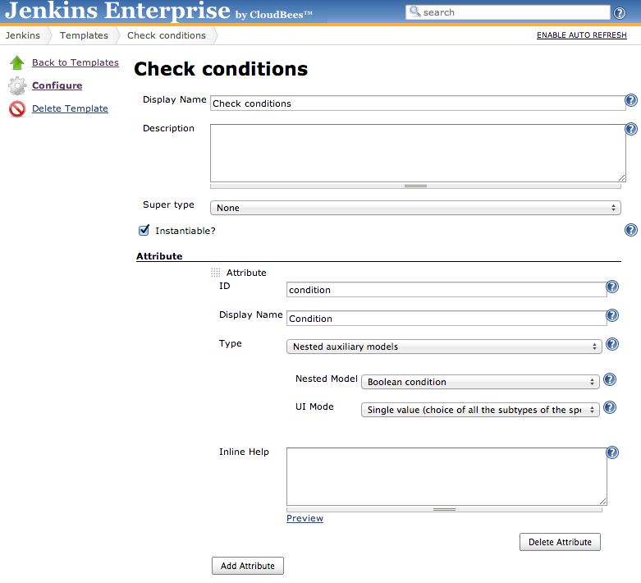

Ensure the transformer is set to “Sets some variables using Groovy…” and enter the following into the Script field. This text is available at <https://gist.github.com/3997848> so that you don’t have to type in this lengthy text:

def evaluate(c) {

switch (c.model.name) {

case 'Or':

for (c2 in c.clauses) {

if (evaluate(c2)) {

return true

}

}

return false

case 'And':

for (c2 in c.clauses) {

if (!evaluate(c2)) {

return false

}

}

return true

case 'Nand':

for (c2 in c.clauses) {

if (!evaluate(c2)) {

return true

}

}

return false

case 'Log_Match':

return build.log.find(c.regex)

case 'File_Presence':

return build.workspace.child(c.file).exists()

}

assert false : c

}

result=evaluate(condition)

Finally, check “Windows Batch Script?” field and enter the following in the “Shell/Batch Script” field:

echo %condition%=%result%

Phew!

Step 4. Watch our builder in action

Go back to the Jenkins home page and create a freestyle job called “demo-conditions”. Add a build step “Check Conditions” and click “Or”, under which add a “File Presence” with “File Path” set to crash.txt and add a “Log Match” with “Regular Expression” set to “error”.

Click “Save” to complete the setting.

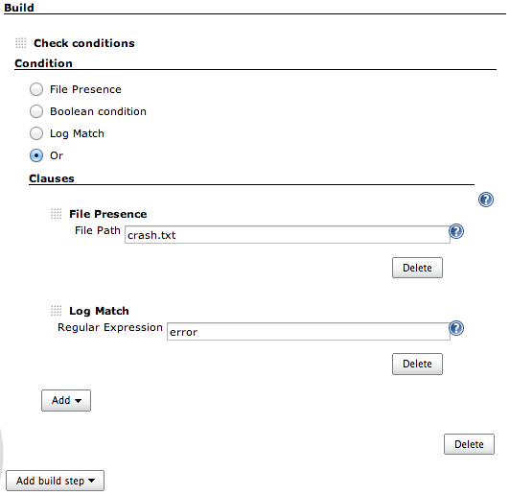

Click “Build Now” to start a build. The console should show

Or;clauses=[File_Presence;file=crash.txt, Log_Match;regex=error]=false

This indicates that the condition was not triggered. Configure the job and add a build step “Execute Windows batch command”, dragging it above “Check Conditions”, and enter the following command:

echo an error occurred

Save and build. Now you should see the following:

Or;clauses=[File_Presence;file=crash.txt, Log_Match;regex=error]=true

Reconfigure the job, changing the batch command to

echo crash > crash.txt

and again save and build; you should again see true since now the workspace has a file crash.txt. (If trying other combinations, remember to click “Wipe Out Workspace” between runs, or edit the batch command to delete old workspace files.)

# Lab 21. Update Center

Goal

In this lab, you will learn how to configure the “Update Center” plugin to setup your own update center.

Step 1. Create a new Update Center

Since the “Customer Update Center” plugin is already installed to your instance, you’ll just need to click on the “New Job” link in the left-hand menu and give your job any name. Select the “Update Center” job type, then hit “Ok”:  
  
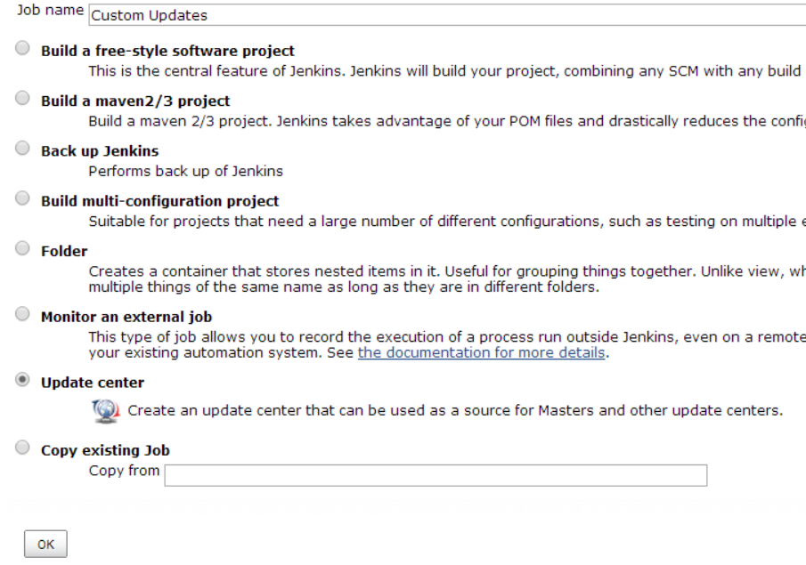

You should be now in the configuration screen. By default, the“Require explicit configuration before publishing” strategy should be selected under the “Plugin versioning” sectionand“self-certified signature” should be selected under the “Certification” section.

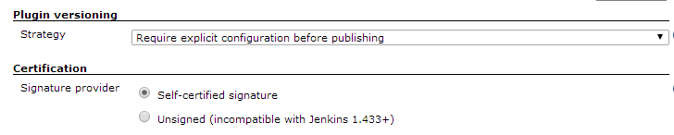

Under the “Content” center, hit the “Add” button and select“Jenkins OpenSource Update Center” as the upstream source:

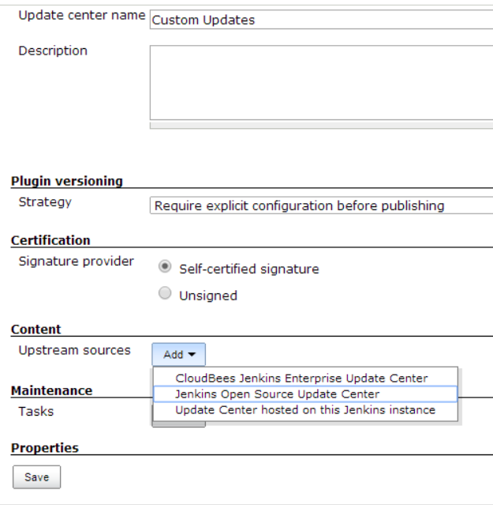

Click “Save” to accept these changes. You now have created the basic setup for a Jenkins OSS update center proxy that we will use to filter available plugins.

Step 2. Run second Jenkins instance

Click the “Update center installer plugin” link on our custom update center’s page,then save it somewhere:

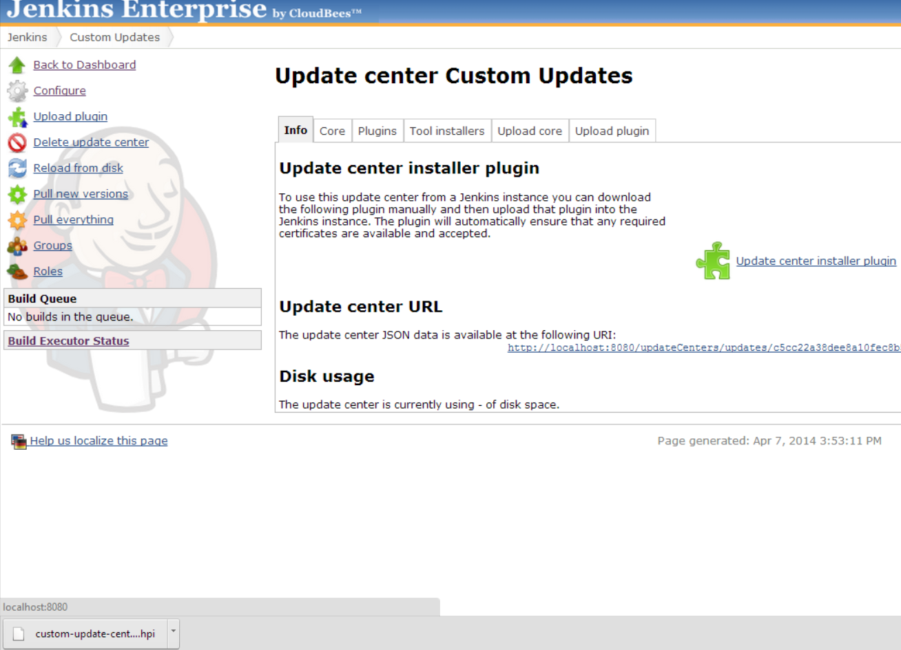

We need another Jenkins instance that acts as the user of our new update center. To do so, open a command prompt and run second Jenkins instance on a separate port (the third command must be typed in as a single line).

> cd c:\

> set JENKINS_HOME=c:\jenkins2

> java –jar c:\cloudbees\tools\jenkins.war --httpPort=9000 --ajp13Port=-1

You should now see the second server start up:

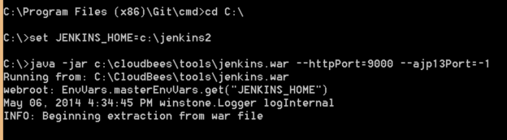

When ready, open browser on <http://localhost:9000/>.

If you see a “This node is standing by” message in your browser, then this means that you forgot to set a second JENKINS_HOME for this instance and the CloudBees HA plugin is currently using this second instance as a back-up master. To fix this, simply stop the instance by typing “Ctrl+C” whil the second instance’s cmd.exe window is active, then run the above commands again WITH the “set JENKINS_HOME” line in addition to the java jar command.

Once you have the second instance running independently of the first, you’ll have to “register” this instance as a separate instance. Just enter your email again in the request for a new evaluation license, then hit next.

Now go to this instance’s plugin manager. Install the “Custom update center installer”plugin that we just downloaded by clicking on the “Advanced” tab of the plugin manager and hitting the “Choose File” button, then selecting the plugin and hitting the “Upload” button:

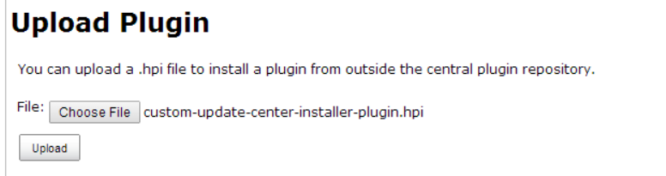

We now need to restart the instance to activate the manually uploaded plugin. Go back to the command prompt, press Ctrl+C to kill this Jenkins:

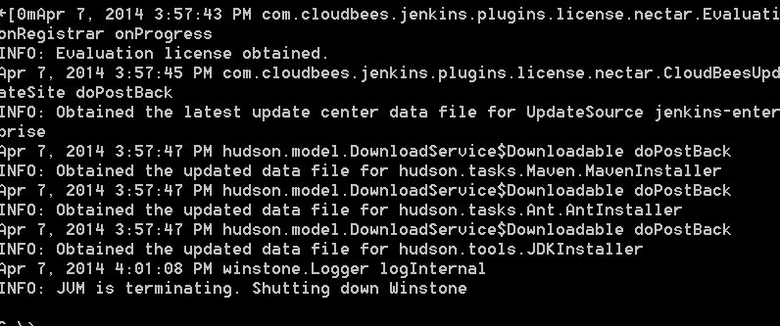

Now re-run the “java jarJenkins.war” command to restart the second instance.

After Jenkins has restarted on port 9000, force it to reload update center metadata using the “Check Now” button. This button is located in the bottom right-hand corner of the same “Advanced” tab that we used to upload the plugin:

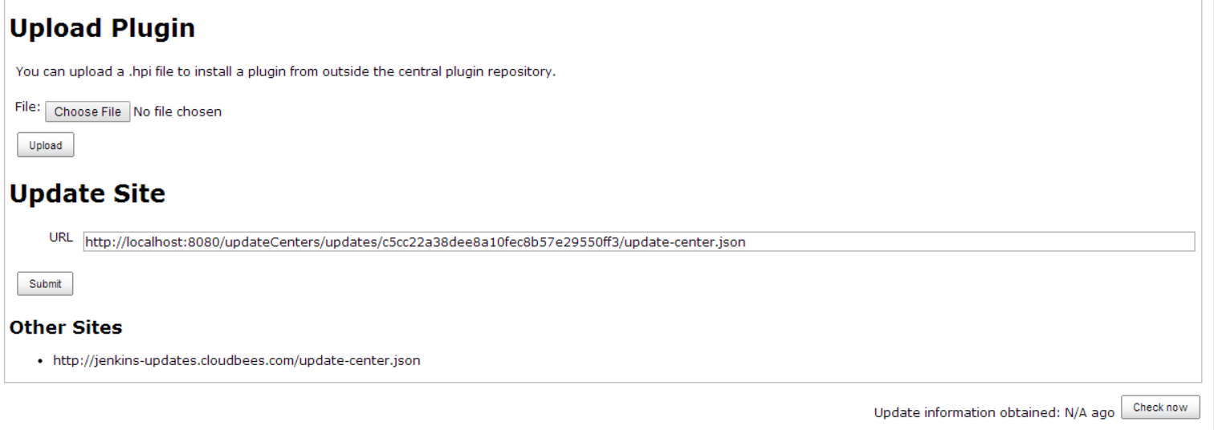

That will cause Jenkins to check for the upstream center’s updates:



Step 3. Populate update center

Now we have our primary Jenkins serving an update center, with another Jenkins subscribed to it. But our custom update center is empty. Let’s select plugins from Jenkins OSS update center to be included into our new update center.

Update Center Plugin only exposes those plugins that it can serve by itself from disk, so we have to *install* them first on this instance. (The act of “installing” a plugin into a custom update center should not be confused with installing a plugin to Jenkins.)

Go back to our primary Jenkins running on port 8080, and open the “Plugins” tab for your custom update center. All available plugins for Jenkins OSS update center should be listed here.

Notice that “available versions” column is empty, indicating no versions are locally stored.

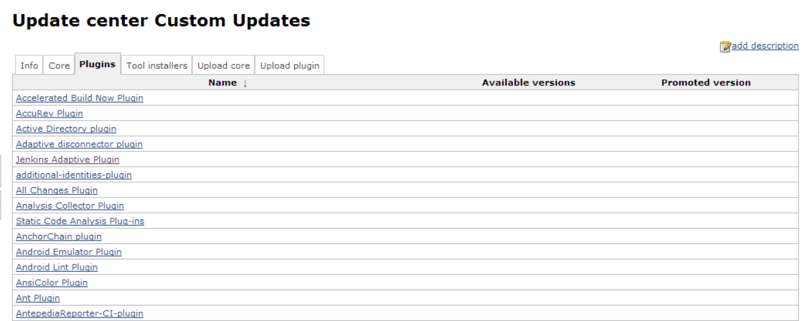

Select a plugin by clicking its name (any one of them would do, but the rest of the lab assumes you choose “cobertura”.)The Update center plugin will let you know which version is available in the upstream update center:

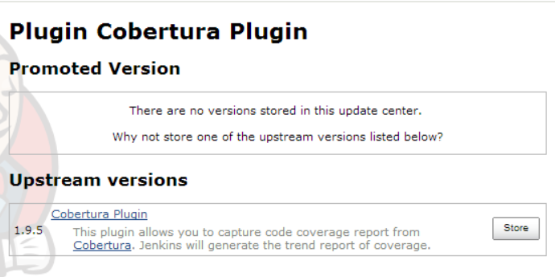

Install this version by clicking the “Store” button. You can see in the build queue a background task being executed by Jenkins to download this plugin into update center.

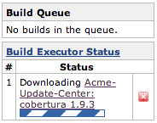

In actual use, you could have used“Pull Everything” action and/or schedule this action as a management task in the update center configuration to get all the available plugins downloaded into your update center. However, this action consumes a lot of network bandwidth and takes a long time, so please don’t do that during the training.

Similarly, we could have used“Pull new versions” action or schedule it to get new releases for already installed plugins downloaded in your update center.

Step 4. Promoting a plugin

After download completes, plugin page for Cobertura plugin has changed to let us select the promoted version of this plugin. The promoted versionis the one that gets visible in our custom update center. As we slected the “Require explicit configuration” strategy, the plugin is installed but not promoted by default. Therefore we have to manually select the version to be promoted by clicking a radio button for either “Latest Version” or Jenkins Cobertura Plugin:

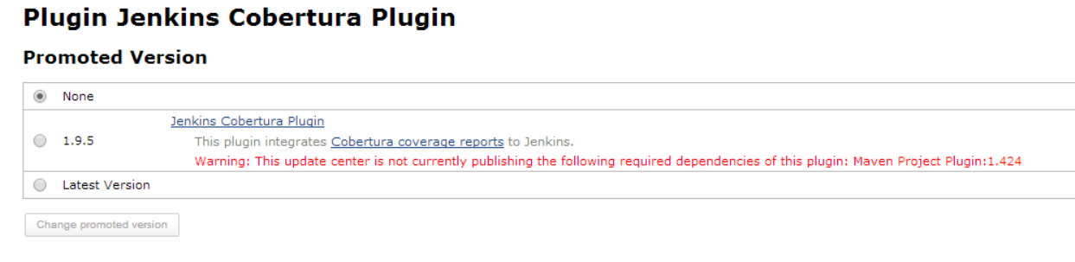

Here you can select a fixed version to be promoted, or just let the update-center get the latest version. (In this lab, this distinction doesn’t matter because chances are that the new version of this plugin will not be published in the next 15 minutes!)

Select the “latest version” for this plugin and click “Change Promoted Version” to promote a plugin.

Back in our custom update center plugins list page, you can check the available and promoted version of plugins in your update center. As expected, cobertura plugin has been promoted.



Step 5. Verify the promotion

On the “Info” tab of your localhost:8080 instance, scroll down to the Update Center URL section and click on theURL linkto see the JSON format of the update center:

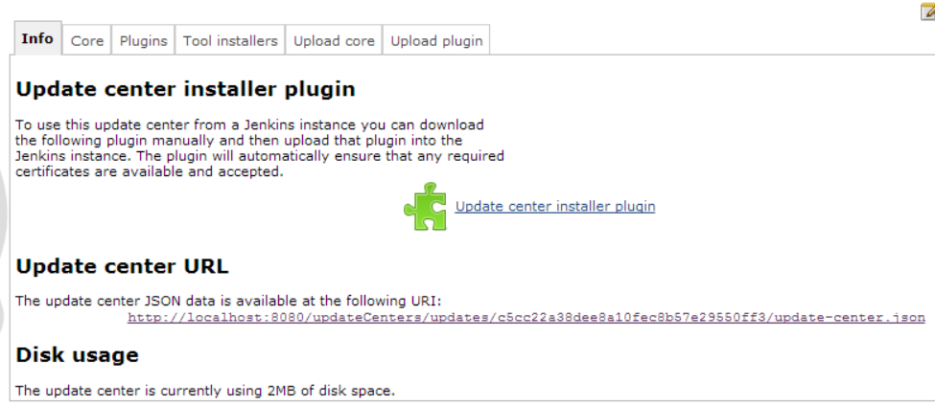

You should see the plugin that you just promoted:

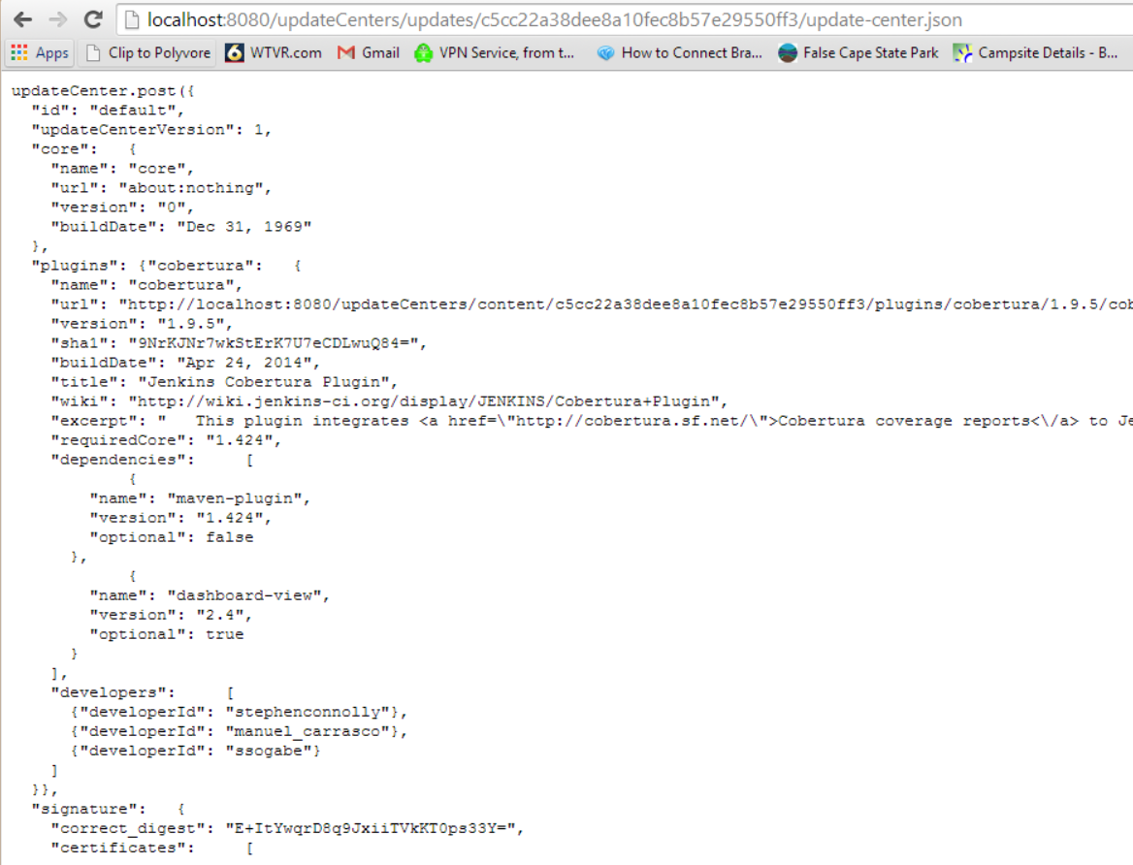

Switch to your secondJenkins instance running on port 9000 and let’s try to install this newly promoted plugin.

Because this Jenkins instance already subscribes to the custom update center, in due time (within 24 hours) it’ll notice that new plugins are available. We can’t wait that long right now, so go to the plugin manager’s “Advanced” tab and hit the “Check Now” button*.* This will force the Jenkins to re-retrieve update center.

Go back to the “Available”tab*.* Promoted plugin should be now available: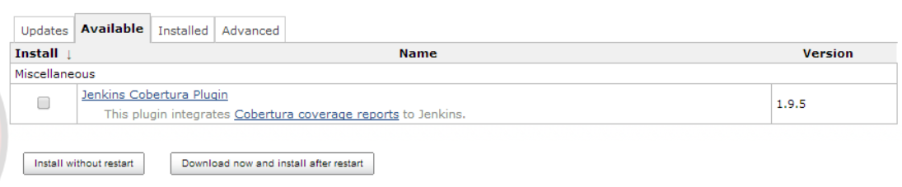

Step 6. Distribute our own plugin

Now, let’s distribute our own plugin. As plugin development is out of scope for this lab, we will just download one from <http://updates.jenkins-ci.org/download/plugins/>

Browse to our custom update center on our primary Jenkins and select the “Upload Plugin” tab. Select the hpi file you just downloaded and upload to Jenkins.

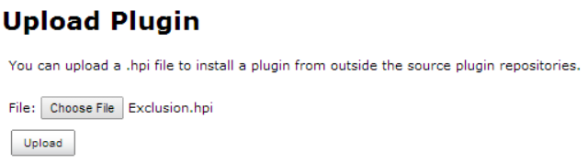

You can check that the uploaded plugin is listed as “installed” and we can now promote it in our update center, like we did before.

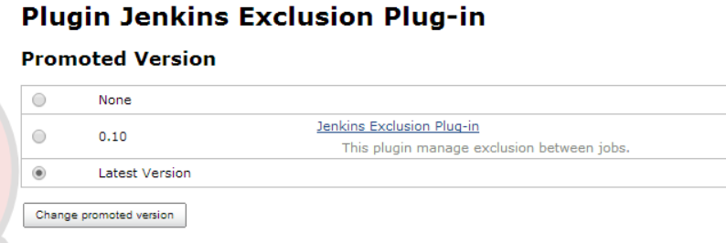

Go back to the 2nd Jenkins instance running on port 9000. Click the “check now” button again in the advanced tab like we did before.

You can then check on client Jenkins that this plugin is now available for installation:

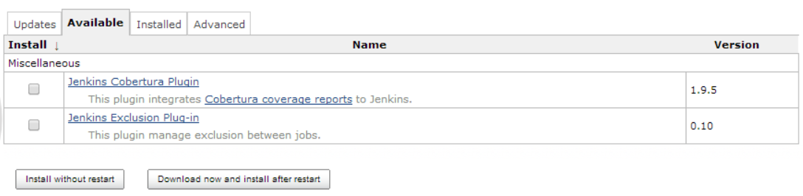

1. In this lab, the admin role is a superset of the reader role, so every member in the Administrators group gets every permission enjoyed by the Read Access group. Therefore, technically speaking, adding the Administrators group as a member of the Read Access group is redundant.